
The Journal of Maronite Studies
is the official journal of the
Maronite Research Institute
(MARI).
ISSN# 1526-5145 since 1997
Publisher:
The Maronite Research Institute
(MARI)
Editor-in-Chief:
Guita G. Hourani
Deputy Chief Editor(s):
Edward J. Brice
Associate Editor:
Catherine Bolton
Copy Editor:
Manell Brice
Reasearch Associate:
Joseph Medawar
Genealogist:
Ross MacKay
Translator:
Kozhaya Akiki
Web Design & Management:
Michael V. Korotaev
Jason Roy
Correspondence to
The Journal of Maronite Studies
and articles being submitted for possible
publication should be addressed
to the Editor.
Individual opinions expressed in the Journal
do not necessarily represent
the views and opinions of
The Maronite Research Institute
or The Journal of Maronite Studies.
The Maronite Research Institute
P. O. Box 18087
Washington, D.C. 20036 - 8087
TEL: (202) 452-5932
Fax: (703) 533-6768
E-mail: mari@mari.org
URL: www.mari.org
A HEALING RECIPE FOR THE THIRD MILLENNIUM
What marks Christianity and sets it apart from other religions of all time, is the commandment of love. This powerful lodestone of the Christian faith is a universal spirit of compassion that fills the hearts of all true Christians and manifests itself in their caring for each other, in lending a hand to those in need and in sharing the joys and sorrows of all humankind as one indivisible body and soul.
It is said that when they needed help of any kind, whether it was food, shelter or security, the early Christians had only to proclaim these words, "Christ has risen" and listen for this echoing response "He is truly risen and is seated at the right hand of the Father". It was through this testimonial declaration of faith that their fellow Christians reach out to help them fill their needs.
Christianity, as the first Christians understood it, was all about love. It began with God, who so much loved the beings of this earth that He sent his only son into the world, as the personification of His love, to save them. For two thousand years now, the shining flame of Christ's love has continued to glow, calling upon all people to follow its light and share its blessings with one another.
In his First Epistle to the Thessalonians, Chapter 5, Saint Paul talks about how we must love one another, how we must comfort and edify one another. He tells us to know those who labor among us and are with the Lord, to esteem them more abundantly and in charity for their work's sake. He instructs us to live in peace with all, to rebuke the unquiet, comfort the feeble in spirit, protect the weak in body, and show understanding towards those who try our patience.
Love is a powerful recipe that never fails. It was tempered into everlasting strength by Christ Himself, through His incarnation, teachings, death and resurrection. It is said that the first Christians applied this recipe so well and vividly that they were instantly recognized by all others as followers of the Nazarene whose great love had bonded them together.
To those who live in fear today and despair of what the third millennium will bring, to those who are pessimistic and say that love and compassion have died in the world, we say that God's love truly endures. We say that the world is made of you and me; we say that because for too long we neglected love, we became part of the problem and that it will be only through resurrecting love that we can become part of the solution. As Mother Theresa advised, "We can accomplish something extraordinary by doing something ordinary with love."
At the dawn of this Third Millennium of Our Lord, let us all in words and in deeds partake of this potion of love to heal ourselves, our communities and our world.
Guita G. Hourani
Editor In Chief
SYRIAC CHRISTIANITY:
YESTERDAY, TODAY AND FOREVER
By Paul S. Russell, Associate priest at The Anglican Parish of Christ the King, Washington, D. C. and Lecturer in Theology at Mount St. Mary’s College, Emmitsburg, Maryland.
This paper was presented at the 37th Annual Convention of the National Apostolate of Maronites, Washington, D.C. USA, July 7th, 2000.
I. INTRODUCTION
It is a great pleasure for me to be here with you today and to have the opportunity to speak to you about a subject that is dear to my heart. It is a daunting thing to be asked to speak to you about your own tradition, but it may be that those of us who live our Christian lives outside of the Syriac tradition are able to recognize more clearly its great riches and peculiar benefits. At least, that will be my task today: to try to tell you many things you already know, and perhaps a few that you do not, and then to try to suggest what these things can show us about what Syriac Christians have done for the universal Church and what they can do for it in the future.
I have decided to divide my remarks into three parts to demonstrate the three parts of the title that Fr. Dominic Ashkar (Pastor of Our Lady of Lebanon Maronite Church in Washington, D.C.) helped me devise: where the Syriac Church has been, where is it now (especially its Maronite component), and where it might go in the future. I will try to describe to you some things about the spread of Syriac Christianity and its influence in India, Central Asia, China and, finally, in England. Once we have examined that spread through space, we will turn to take a look at a piece of writing that can serve as an example of some of the Syriac tradition’s characteristic qualities. Those two elements: the geographical spread of its influence and the quality of its Theology will, I hope, give us some idea of what we are referring to when we talk about what Syriac Christianity can do with its tradition as it looks forward to the future.
We will begin in the past, as our faith did and as Christians always do when they try to understand themselves. That is why The Letter to the Hebrews 13:8 can speak of Jesus Christ “yesterday, today and forever” and why we speak of Syriac Christianity in the same way. We have a history we can trace and tracing it is how we come to know ourselves. So, we begin at the beginning of the Church’s spread: at Pentecost.
II. SYRIAC CHRISTIANITY: YESTERDAY
And when the day of Pentecost was fully come, they were all with one accord in one place. And suddenly there came a sound from heaven as of a rushing mighty wind, and it filled all the house where they were sitting. And there appeared unto them cloven tongues like as of fire, and it sat upon each of them. And they were all filled with the Holy Ghost, and began to speak with other
tongues, as the Spirit gave them utterance. And there were dwelling at Jerusalem Jews, devout men, out of every nation under heaven. Now when this was noised abroad, the multitude came together, and were confounded, because that every man heard them speak in his own language. And they were all amazed and marveled, saying one to another, Behold, are not all these which speak Galilaeans? And now hear we every man in our own tongue, wherein we were born? Parthians, and Medes, and Elamites, and the dwellers in Mesopotamia, and in Judaea, and Cappadocia, in Pontus, and Asia, Phrygia, and Pamphylia, in Egypt, and in the parts of Libya about Cyrene, and strangers of Rome, Jews and proselytes, Cretes and Arabians, we do hear them speak in our tongues the wonderful works of God. (Acts 2: 1-11)

This scene of the Pentecost, from the beginning of the second chapter of The Acts of the Apostles, reminds us of two important things:
A: From the very first, the Church spread from Jerusalem to the East, since we can see that many of those converted on that first day of Pentecost were from the East: “Parthians [Parthia was the empire located just East of the Roman Empire that included roughly what we now call Syria, Iraq, Iran and Afghanistan], Medes [Medes might be Persians, or people from Asia Minor]...dwellers in Mesopotamia...Arabians [these two we all can recognize]”, and
B: The new faith of the Church was carried first to the world by Jewish believers in their own languages. Toward the East, that language was predominantly Aramaic. What we call “Syriac” is a western form of Aramaic usually written in a different alphabet than the Hebrew and Aramaic Old Testament.
As much of the very early history of the Church as we can discover follows this pattern quite closely: traveling Christians: missionaries, but also, more usually, Christians who were traveling anyway on business, carried the faith with them as they moved to the East and South. We can trace them East to Edessa, which would become one of the great centers of the Syriac speaking Church, to India, to Persia, to central Asia and even on to China, where we have physical evidence to record the arrival of Christians there no later than 635 AD.
We all know something of the spread of the Church to the West, because that is where we live. We know of the missions to the Romans and the Goths, to the Slavs and the Norse Vikings, to the Irish (this is very fashionable now) and even to the American Indians. I would like to tell you just a few things about the Church’s spread to the East, to offer you just a few drops from the great ocean of the history of the life of the Syriac Church, and to try to demonstrate to you a few points that I think are important for understanding the genius of your tradition. I will try to convince you of the truth of three ideas:
A) The Syriac Church is a unifying tradition.
B) The Syriac Church offers culture and learning wherever it goes.
C) The Syriac Church has a creative and intelligent theological voice.
If we imagine the map of the world spread out in front of us, we would see the Latin Church in the West (to the left), the Greek Church in the middle, and the
Syriac Church to the East (on the right). Over the course of time, each of these traditions worked hard to spread the Gospel to those with whom it had contact. The Latins moved through Western Europe and North Africa, the Greeks moved northwards through Eastern Europe and southwards into Egypt and Ethiopia, and the Syriac Christians spread through the whole of the great landmass of Asia. As we look back at this process, we can see that, while the use of Latin spread with the western Church and served to bind it together as a group, that unity became more and more one that excluded their brothers to the East so that, by the time of the ecumenical councils of the Fifth Century (Ephesus II, 449 AD), we have stories of the legates from the West being unable to join in the discussions or understand the business of the council because they no longer could talk to their brother Christians. Latin Christianity and Greek Christianity had grown apart. (I am hardly hostile to the western Church and its tradition. I speak as a person whose family background is a mixture of Scottish, English, Welsh and French. All of these are groups that were evangelized by the Latins at the very edge of their world. For my ancestors in the western reaches of the Latin Church, there was a great benefit in being offered Christianity in a form that could be shared with people all the way to what is now Yugoslavia, but their Christian brothers to the East were cut off from them by barriers of language more than of distance.)
The Greeks were always more open to allowing groups to make their own way forward in the faith than the Latins were (as the Orthodox traditions of worship that continue to be active in many languages attest), but they, too, tended to offer their converts what they knew, which was the tradition of the Greek East.
When we turn to look at the tradition of Syriac Christianity, I think we see something different.
A. The Syriac Church as a Unifying Force.
I would like to share with you some pictures produced by the Syriac Church that will illustrate some of this unifying quality in its tradition. I think they help make my point more convincing.1

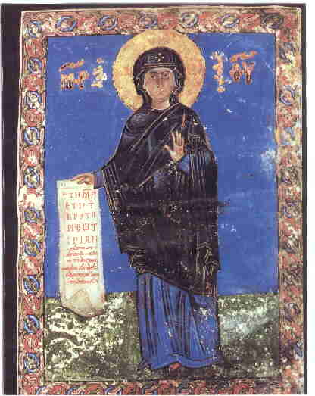 | 1) This comes from a Gospel Book, ca. 1054 AD, in the library of the Syrian Orthodox Patriarchate in Damascus. Notice that the scroll Our Lady holds has writing in both Greek and Syriac on it. The Syriac says: “My soul doth magnify the Lord and my spirit doth rejoice in God my Savior. For He hath regarded the lowliness of His handmaiden.” I think that the Greek comes first because the icon-writer knew that the New Testament original was in Greek. The writing by Mary’s head is also bilingual. The book this is found in is a book of Gospels in Syriac. Are these people cutting themselves off from their fellow Christians on the basis of language?
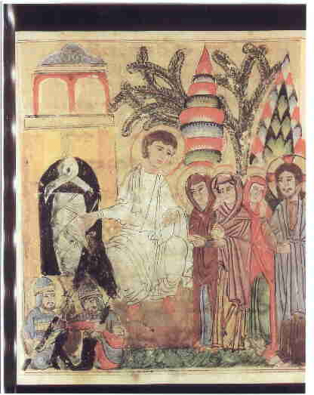
2) This icon of the Resurrection, from 1219-20 AD, is found in the Vatican Library. Notice how it contains elements that reflect both the current events in the lives of the Syriac Christians (the soldiers look Asian or Turkish as Muslim soldiers of the time increasingly were) and the customs of the greater Church. (The figure of Jesus tries to be in tune with the standard pattern of the western Christians--the Greeks.) The Syriac Christian artist is looking both East and West.
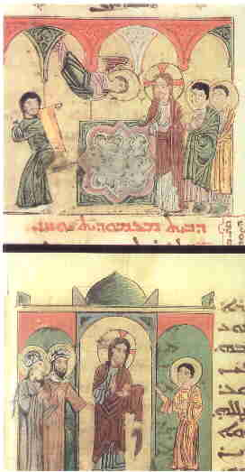
3) This is from the same manuscript as the last and shows two scenes of Christ with the paralytic. He cured, the one who had been lowered through a hole in the roof by his friends. “Take up your bed and walk.” Notice how the disciples are dressed some as Romans (upper right) and some in a more eastern style. The artist has both good historical knowledge and a sense that the life of Christ was lived in the Middle East. Western books might have the figures in western dress of their own time: Pilate in Medieval armor and Herod dressed like an Italian prince.

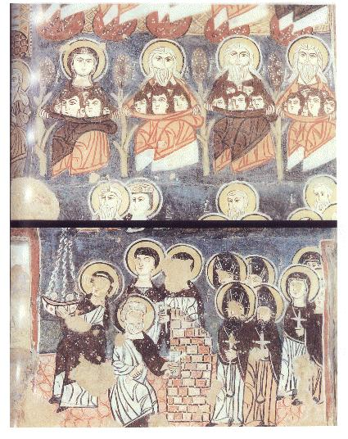
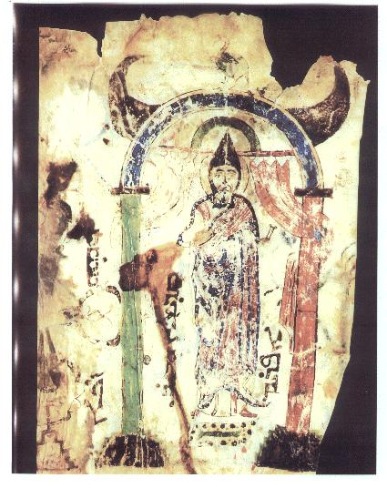
4) These scenes are found on the wall of the Monastery of Moses the Ethiopian in Nebk, Syria. The top scene is of the Virgin, Abraham, Isaac and Jacob saving souls at the Last Judgment; the bottom shows St. Peter opening the gates of Heaven. Notice how western St. Peter looks (being associated in the artist’s mind with Rome, of course, and standing for the Western Church), while the saints entering the gates have more in common with the inhabitants of the monastery. The artist imagines both East and West present in the Kingdom after Judgment.
5) This little figure is St. Ephraem, the great hymn writer, who lived in Nisibis for most of his life and died in Edessa in 373 AD. This is in the library of the Syrian Orthodox Patriarchate in Damascus and was painted in the 12th century. Notice how this authentically Syriac Christian figure is shown in an authentically Middle Eastern way.

These five pictures have shown us that the Syriac Christian artists had a clear idea of the breadth and variety of the whole of the Church and tried both to represent that variety and to help the different parts of the Church remain united in their art (and in the minds and hearts of those who looked at their works).
Let us turn now for a moment to some physical monuments and remains of the spread of Syriac Christianity.
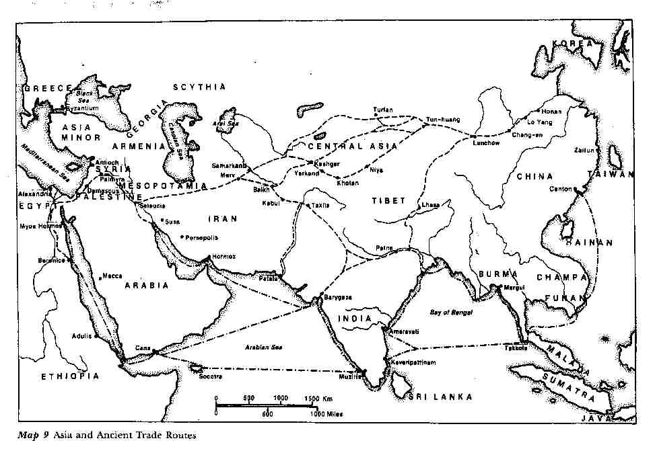
6) This is a map of Asia with routes of travel marked on it. You can see the various paths by which people customarily journeyed. It is precisely along these lines that we can trace the spread of the Syriac Church.

All the traditions we have about the coming of the Gospel to India agree that it came from or through Mesopotamia to get there. Whether it was brought by the Apostle Thomas himself (and there is certainly no reason why it could not have been), or whether his original evangelism was extended by other brave souls whose names we do not know, it is clear that Syrian Aramaic Christianity is what was offered to converts in North and South India.
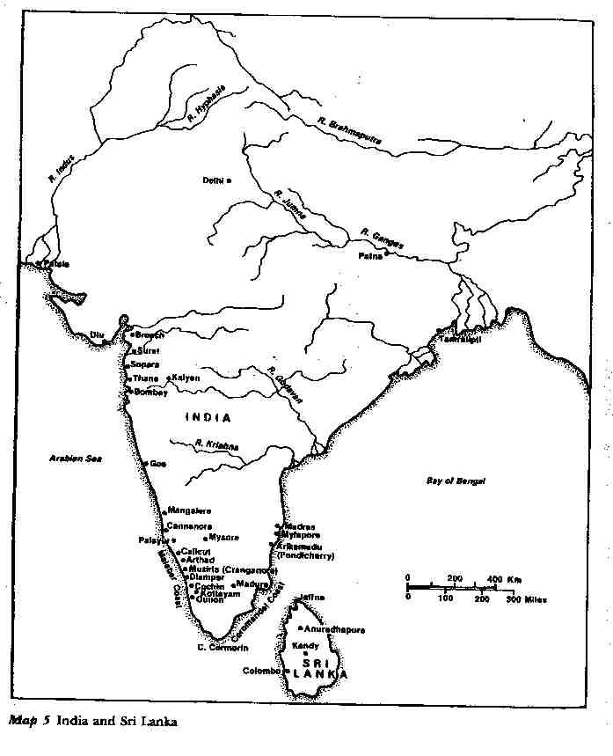
7) This map shows the locations of known early Christian sites in India and Sri Lanka. You can see that they are grouped in just the areas one would expect if they were created by people moving along the lines we have suggested. One of the points to remember in this is how much the ordinary lay people were involved in the spread of their faith. There were many heroic clerical missionaries, of course, but most people seem to have come to the Church through contact with the ordinary faithful. (That lesson is one we should all keep in mind when we think of the present need to spread Christianity to those around us.)
How did they present it to their listeners? The evidence of these crosses seems to me to argue that they couched it in terms that would meet the converts on their own level (as the native language inscriptions shows) while guarding that part of their message that would continue to connect their followers with their Christian brothers and sisters back in Mesopotamia, Persia and the Holy Land. Because Asia is one great landmass, Syriac Christians lived in a world where many different types of people had easy contact with one another (which was often not the case for Christians in the West), they seem to have understood that to keep the lines of that contact open would allow for a broader and more vibrant Church than if each local area had to fend for itself. Examples of this are many, but I will only mention that it was the custom for Bishops in the Indian Church to travel to Persia to be consecrated (not an easy feat, even in the 21st century!)2 and that this seems to have been the regular practice for most of the life of that Church. It is also known that the Syriac Christians living all the way to the East in China communicated regularly with their ecclesiastical superiors in Persia (a journey often taking more than a year--each way!) In fact, in the 14th century, the Church of the East had for its Catholicos (Patriarch) a monk who was born north of Peking in what is now China, and that Patriarch sent a legate from Baghdad (who was also from China) to the Christians of Western Europe. This legate, Rabban Sauma, visited Constantinople, Italy, and France, and had audiences with the kings of France and England and with Pope Nicolas IV. (He was received with respect and honor in the Vatican and allowed to celebrate Mass at the altar in Saint Peter’s, a Mass which the Pope attended.)3
Now that we have had a brief look at the manner of the Syriac Church’s spread in India, which produced a Church that continues to the present day. Let me show you a few things from the Syriac Christians of Central Asia:

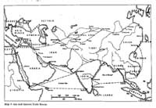 | 8) This shows a rough outline of the Silk Road. You can see something of the barrier that Inner Asia affords to those who wish to cross it as you look at these next two views of that part of the continent. This map emphasizes the mountain ranges in the center of the continent. You can see why it is often called “the roof of the world”.
B. Effects on Culture
The Syriac Church was affecting many groups of people it met. We see evidences in Manichaean and Soghdian texts discovered in what is now known as Uzbekistan.
The fragments of a psalm text in Syriac from the 9th to the 10th century found in Uzbekistan and a Manichaean text from a Manichaean temple in Kocho (8th-9th century) in which the figures are Chinese in appearance, with traditional high white hats worn by Manichaean clergy, but their language is a script taken from Syriac. Mani was the first in a long line of people who have claimed to be Jesus Christ returned and the connection to Christianity that forges for the Manichees seems to have allowed them to piggyback on Christianity through much of the area the church had managed to penetrate. Saint Augustine was a Manichee for more than a decade, meeting with the religion in North Africa, and these Manichees were all the way on the border of the Chinese Empire, still clinging to Syriac writing from an idea that it is culturally sophisticated. There is Manichaean prayer written in the Uighur language (a Turkic tongue) clearly shows that the alphabet is Syriac. This indicates that the Manichees using the Syriac alphabet were not only transplanted Mesopotamian people using their own national script, but also people native to Central Asia.
There is a Soghdian text, also with Syriac script. Soghdian was the language of an important merchant people living along the Central Asian Silk Road. Bukhara and Samarkand were in their sphere of influence before the arrival of Islam. This is also in the area we now call Uzbekistan. The Soghdian people flourished in the period following 600 A.D. Soghdian was the preserver of a lot of Christian writings in this area.
The following photos and descriptions will give you an idea about the magnitude of the influence that the Syriac Church have had on those it has converted and on those it has not. Remember that this influence was being felt in a world where many strong cultures were active. These examples should not be thought of as being influences that Syriac Christianity wielded because it had no competitors. The effects I will try to show you were felt against a backdrop of vibrant, attractive options.
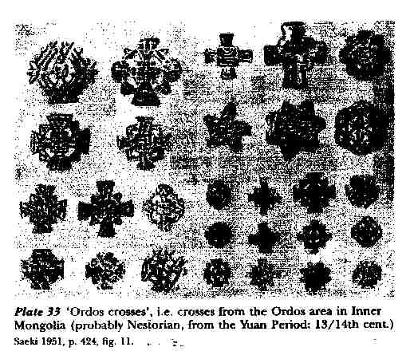
1) This photo shows the wide variety of embroidered crosses produced among the Asian Syriac Christians of what we would call the early Middle Ages. These crosses and others like them are always common finds in all parts of globe where the Church has spread because of the use of so many kinds of linens in worship.

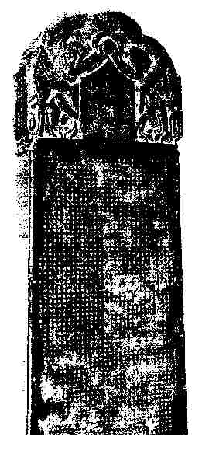
2) This photo shows the famous monument found at His-an-fu in 1625. His-an-fu was the ancient and original capital of the Chinese Empire. You may remember the many thousand clay soldiers discovered a few years ago in China and often shown in pictures in the West. (National Geographic did an article on them a while ago.) They were also found in His-an. This monument is of particular interest for the history of the spread of Syriac Christianity. The stele was unveiled on February 4, 781 and speaks of the arrival of Christianity in China as having happened in the year 635 AD. This marks the “official” arrival of Christianity in China. There may well have been Christians in China before that time.4

To begin with, the Chinese text of the monument refers to Christianity as “the Syrian Luminous Religion” (its official legal name in the empire), which makes it clear where the Chinese government thought the Gospel was coming from. The text also refers to God as “the Lord, Alaha”, which is clearly Syriac. Notice what the decoration of the Cross atop the stone shows us.
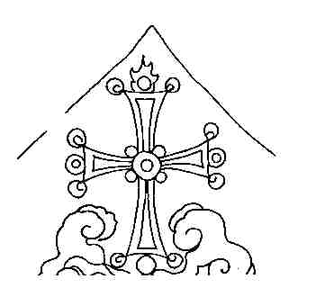
3) The Cross rests on the cloud of Islam and on top of the lotus of Buddhism. The Church was competing in China against other non-Chinese religions and claimed to be winning. (The Syriac Christians in China were not timid.)

At the bottom of the stone are carved the names of the clergy in Syriac script and then in Chinese equivalents. Some of the list includes Yohannan, Isaac, Joel, Michael, George, Ephraim, David, Moses, Abdisho, Simeon, Aaron, Peter, Job, Luke, Matthew, Ishodad, Constantine (!), Sargis, Zechariah, Koriakos, Emmanuel, Solomon and Gabriel. We have no way of knowing what ethnic background these people came from (they might have been Middle Eastern, Chinese, or anything in between), but it seems clear where their Christianity was coming from. Even 2,000 miles from the land of spoken Syriac, the Church was maintaining its linguistic ties with its brothers back home.
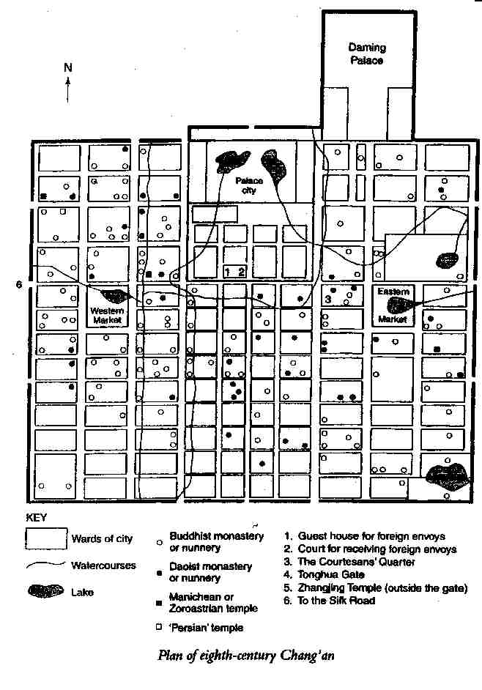
4) Here is a map of Hsi-an in the 700s, the time of the monument.5 A place is marked “Persian temple” on the map, which I take to be a church. Zoroastrian sites are listed separately, and no other religion seems likely. The Syriac Christians in Hsi-an corresponded with their fellows in Persia for support and news about the Church, so having the Chinese call them “Persian” or “Syrian” makes equal sense. Both places were as far away as the moon for the Chinese of that time, anyway.

The capital of China at that time had more than 1,000,000 inhabitants, according to the latest guesses. The lay out is easy to understand: trade arrived from the West (left) and East (right). The Christian church, as one would expect, was near the gate through which the Gospel arrived along the Silk Route. I think this fact, which places the Christians among the traveling merchants and those who had contact with them, shows that the Syriac Christians at the other end of the world in the 700s were spreading the Gospel through personal witness and contact, just as those witnesses of Pentecost did 700 years before them. People who wanted either exotic items from the West or instruction in the Christian faith would have known where in Hsi-an those things could be found.
What have we seen of the Church’s influence, then? The Church was passing along its own writings in its language of worship and those around it were spurred to write down their languages (which they had not done before) in the script that the Church brought with it. We have seen, also, that the Church was still associated in the minds of those around it with the Syriac Christians who brought it with them and that it still (even in Chinese) spoke of God with the Syriac word “Alaha”. The Chinese name for the Church, “the Syrian Luminous Religion”, shows us that this connection was strong, and the location of the church building in the city supports that connection.
Before we leave this section of our discussion, I would like to reiterate one point about the role of the Syriac Church in this area: it seems clear to me that the Church was serving as a unifying force among the various Silk Road peoples who made up its membership and that this influence could even spread beyond its boundaries and include those who were not converted to the Faith. Rather than dividing people, Syriac Christianity seems to have served to give them things in common across racial and linguistic boundaries.
Before we leave off considering influences, I have one more thing I would like to tell you about with regard to the Syriac Church’s influence in the past. For this, we must focus our gaze all the way at the other end of the world from the Chinese Empire, on England at the time of the Anglo-Saxon kingdoms.6 It is a mistake to think of Syriac Christianity’s influence as confined to the Holy Land and points to the East; it has been of importance at various times in my own national Church, the Anglican Church, as well.
There were Christians in Britain during the Roman Empire. There seem to have been bishops in London and York, at least. This Church was poor and seems to have been small. It seems to have dwindled to the point that, by the time of Pope Gregory the Great (590-604), the island seemed, to outsiders at least, in need of being reconverted. (We seem to be fast approaching that situation again, I fear.) After Saint Gregory had sent Saint Augustine of Canterbury to Kent, where he became the first Archbishop of Canterbury, the Church in England revived, but was still in an uncertain state.
In 664, with turmoil setting in, Pope Vitalian thought it best to send another archbishop from Rome to settle things down. He tried to send a monk named Hadrian (“an African by race”, Bede called him) but instead settled on an elderly (66 years old) monk from Tarsus (Saint Paul’s home) called Theodore. (Hadrian came as one of his companions, so the group was very international in its make-up.) The new archbishop who arrived in the rugged western island was a scholar from the Middle East, which must have made him a fish out of water in the England of the 660s! Theodore, to everyone’s surprise, lasted more than 22 years as archbishop!
Scholars think that Theodore knew Syriac. He is likely to have begun his theological study in Antioch, where Greek and Syriac were in common use at that time. He may even have been to Edessa.
Theodore set up a school in his monastery in Canterbury and manuscripts of notes on Scripture survive that were written by his pupils. Often, the particular comments are clearly labeled as coming from Theodore or Hadrian. At a number of points, scholars have identified comments as having been drawn from the works of Saint Ephraem the Syrian. One of these comments even mentions Saint Ephraem by name, which shows that the English students in the school (where the language of instruction was Old English) knew that they were being taught the doctrine of the great Syriac Doctor.
Some of the passages from Syriac writers that are reflected in the commentary notes the students produced are not known to have existed in Greek or Latin translations. This would mean that, unless translations were made and all trace of them is now lost, we have evidence of direct influence of Syriac Christianity on what was taught to Anglo-Saxon students in Canterbury and then, presumably, through preaching and teaching, to their laity. Some scholars think that Theodore brought Syriac books with him for his own use when he arrived in England. These would most likely have been works of Saint Ephraem.
The evidence seems to support the conclusion that Theodore of Tarsus, and those who accompanied him, brought with them, either in their heads or written in books (or both) some knowledge of the teaching of writers from the Syriac Christian tradition, with Saint Ephraem prominent among them. This means that at both ends of this process: at Antioch and elsewhere in the Middle East, and in Canterbury in the Kingdom of Kent, the Syriac tradition was attractive enough to these Christians to be noticed and studied and passed along. Because this all happened early in the history of the Church, the walls of language and politics had not yet blocked travel and contact between Syriac and Greek, Greek and Latin and Latin and Anglo-Saxon. So, the teaching of the East was able to make its way all the way to the West, past the Pillars of Hercules and out to the isles in the Western Sea. By the year 700 AD, Syriac Christianity had spread its influence to China, India and England: all the bounds of the world as they were then known, except only the North, whose Slavs and Scandinavians would remain pagan for another 300 years.
Before we leave England, though, I would like to point out that Syriac Christianity has not only influenced us in the distant past. When Syriac and Syriac writers became known again in England, after the Reformation, its influence began to be felt again. To my knowledge, more attention has been paid to tracing this in the 1800s than to finding it earlier,7 but the pattern is clear: when English Christians have had access and exposure to Syriac Christian works, these writings have had a profound effect on us. Our ideas of the mystery of God and the sacramental nature of the world have been deepened and enriched by being exposed to your tradition. Recently, we have not felt this effect as much as at other times, but I hope (and my own work is an attempt to help spur this along) that a renewal of interest and benefit is in the beginning stages now.
C. The Syriac Church’s Theological Voice
We will now leave off discussing the Syriac Church’s role in spreading culture and learning and turn to a quick look at its theological voice. What can I show you in a few minutes about a topic that a lifetime cannot exhaust? We might begin by reminding ourselves that Syriac Christianity has never made an idol of its Theology. St Ephraem, the greatest of the Syriac Fathers says in Hymns on Faith 4.13:8
This is suitable for the mouth:
That it might praise and be still and,
If it should be asked to run on,
It would entirely resist, in silence.
Then it will be able to comprehend,
Unless it runs on in order to comprehend.
Stillness is able to comprehend
More than the insolent [person] who runs on.
Saint Ephraem means that when we are speaking about God we had better be ready to realize our own shortcomings and keep silent so that we do not fall into the sin of presumption by boldly attempting to describe Him Who is beyond us in every way. Still, we are religious creatures and living our religion requires some speaking about God, and we must certainly speak to teach our religion to our children. (Saint Ephraem certainly knew all this. He was, himself, a great talker about God, after all.) So, I would like to show you just one element in Syriac Christianity that will serve to illustrate its sensitivity and creative power. I would like to show you a taste of the things it has to say about Our Lady, the Blessed Mother, the Virgin Mary, and the Theotokos.
These passages I will show you are taken from a Dialogue Hymn that shows the Holy Virgin in conversation with the angel Gabriel on the occasion of the Annunciation. I know that these hymns are in use in your liturgies and that you know much more about them than I do (because Theology is best learned in worship and prayer. This is the basic insight Fr. Dominic Ashkar makes use of in his book Transfiguration Catechesis, and the universal Christian tradition would enthusiastically agree.)9 Still, I would like to tell you how these lines appear to me, as I stand outside your Church, looking in.10
The first stanza of the hymn reads:
O Power of the Father who came down and dwelt,
Compelled by His love, in a virgin’s womb,
Grant me utterance that I may speak
Of this great deed of Yours which cannot be grasped.
The first thing I notice is that the hymn is theologically and religiously serious. It makes the point, through the voice of the narrator, that it is only with the grace of God that we can hope to speak of the Incarnation of God the Son, without which we can have no understanding of the divine nature and without which our ability to approach God would be much more restricted.
As we read this hymn, we discover that when Mary first hears the words of the angel, her instinct is to push away his message because it seems too good to be true:
Mary 18:
I am afraid, sir, to accept you,
For when Eve, my mother, accepted
The serpent who spoke as a friend
From her former glory was she snatched away.
This is not only psychologically astute on the part of the writer of the hymn, for it seems to me that a smart girl should have been cautious toward strangers who appear to offer her something beyond what seems reasonable, (I hope my daughters are learning similar caution, for it will serve them well in life), but this attitude shows the Holy Virgin as a careful and intelligent religious thinker. She knows that the relations between God and human beings have a history and that that history is meant to guide us in our dealings with the Lord in our own lives. Mary has learned the lesson of the Fall from the Garden of Eden and does not mean to make that mistake again. She is shown to us clearly as Eve’s superior: a woman who can start our race back on its road to Heaven, instead of pushing us farther into the troubles we have already made for ourselves.
The hymn continues, a few stanzas later (stanzas 21-22)
Angel 21:
The Father gave me this meeting here
To bring you the salutation and to announce to you
That from your womb His Son will shine forth,
So do not answer back in contrariness.
Mary 22:
This meeting with you and your presence here is all very fine,
If only the natural order did not stir me
To have doubts at your arrival
About how in a virgin there can be fruit.
The angel’s temper is beginning to fray (angels are probably not used to back-talk), but Mary’s concerns are not frivolous. More than that, Mary’s doubt is not a sign of a lack of faith, but rather a sign of the strength of her faith. She will not acquiesce automatically to something that does not fit into her religious sense of what God is and how He works. She does not accept as true something that violates the natural order of God’s creation unless she has some reason to think that God is choosing to over-ride His general arrangement of things in this particular instance. This caution is a sign of intelligent reverence, not of confusion or of a desire to cause difficulties. So, they continue, a bit further on:
Angel 33:
He will come to you, have no fear,
He will reside in your womb, ask not how.
O woman full of blessings, sing praise
To Him who was pleased to be seen in you.
Mary 34:
Sir, no man has ever known me
Nor any ever slept with me;
How can this be, what you have said
For without such union there will be no son?
Angel 35:
From the Father was I sent
To bring you this message, that His love has compelled Him
That in your womb His Son should reside,
And over you shall the Holy Spirit reside.
Mary 36:
In that case, o angel, I will not answer back:
If the Holy Spirit shall come to me,
I am his maidservant, and he has authority;
Let it be to me, Lord, in accordance with Your word.
Once Mary has seen that this promised event is one that connects with and fulfills her faith in God (as the coming of the Holy Spirit would do), she is eager and willing to do her part. You notice that stanza number 36 echoes the words of Mary in Luke 1:38: “Behold the handmaid of the Lord. Be it unto me according to Thy word.” This hymn is both creative and fully scriptural, at one and the same time. Before we leave this hymn, let me just show you that the characteristic Syriac religious reluctance to speak about the Divine Nature is not lost as a result of the Incarnation:
Mary 46:
I should like, sir, to put this question to you:
explain to me the ways of my son
who resides within me without my being aware,
what should I do for him so that he is not held in contempt?
Angel 47:
Cry out ‘Holy, holy, holy’
Just as our heavenly legions do, adding nothing else,
for we have nothing besides this ‘Holy’,
this is all we utter concerning your Son.
This is just the reaction that Saint Ephraem advocated in that first passage we looked at: “This is suitable for the mouth: that it might praise and be still....” The angel wants Mary to praise the infant Jesus and then to hold her tongue. The Syriac tradition consistently holds to the idea that appropriate speech is required of us, but that more than that is not permitted.
What do we see of Syriac Christianity in these few lines? I see at least two things:
1) This is a serious work of theological writing. It is careful about what it says and keeps to the boundaries it sets itself.
2) This hymn has a clear picture of Our Lady in mind: she is not a “plaster saint”, who looks good but has no personality, she is a human individual with her own ideas and concerns. She is a model of religious devotion for her willingness to do the will of God, but she is a model of theological devotion because her belief and obedience are not blind and unreasoning, but intelligent and thoughtful. She is not the model of those who would make of the Church a mindless cult where you have to leave your mind and ideas at the door in order to gain admittance; she is the model of a Church that will demand of its members the highest degree of intelligence and maturity. I think it is these qualities that have produced the glories of the Syriac tradition and are its hope for the present and future.
III. SYRIAC CHRISTIANITY TODAY
That brings us to “today”. Now that we have examined a few ways in which the Syriac Christian tradition has spread its influence in the past, and have said something about its characteristic theological vision, what can we say about the place of Syriac Christianity and especially of the Maronite Church in the world today?
The Syriac tradition has riches in its possession that no other branch of the Church possesses, but what good is it to have a lighted candle if you just put it under a bushel basket so no one can see its light?11 We are called to “let [our] light so shine before men, that they may see [our] good works, and glorify [our] Father which is in Heaven”. How is the Maronite Church to do that? We must think for a moment about what you are and where you are located in the Church and in the world.
The Maronite Church is unique in that it is an entire Syriac Church that is in full contact and communion with the Church in the West. The fragmentation of Syriac Christians has a long and tragic history and continues to be a source of pain and a cause of wasted energies among many Syriac Christian groups in our own day. Maronite Christians, though they have a long and noble history of suffering for their faith, have escaped the family quarrels of other Syriac groups, which is not a small blessing. As a part of the Roman Catholic Church (which is really more a family of churches than one single body), the Maronite Church enters fully into the life of the Church throughout the world and has access to Christians of all nations and backgrounds. There are Maronites found in their native land of Lebanon, in Europe and in the New World. Maronites study in universities and seminaries with Catholics (and non-Catholics) who will carry the Gospel into every corner of the globe. (My first teacher of Syriac was a Maronite priest, Father Joseph Amar, who now teaches at Notre Dame in Indiana.) You Maronites are organized as a church and as a people, which greatly increases your ability to muster your resources to achieve the goals that you set yourselves. If you set yourselves the goal of being the western world’s window to the riches of the Syriac Christian tradition, I think that you can do it, both because of your unity and the strength it affords you and because of your living among the Christians of the West. I must warn you, though; the West does not know the riches you have to offer them.
Let me tell you a story that will show you how little those around you know about you. During the last week of May this year, I attended, as I do three years out of four, the meeting of the North American Patristic Society at Loyola University of Chicago. The president of that organization this year was an Eastern Orthodox laywoman named Susan Ashbrook Harvey, a very good scholar, who teaches at Brown University in Rhode Island. Because she is a specialist in the Syriac tradition, she used her presidential address to display to that group some of the wealth of your tradition. (She made use of several dialogue poems about Mary to show how Syriac Christians have been astute enough to realize that one of the central messages of the gospels about the Incarnation is that they tell the story of real people making real choices to obey and further the work of God in the world. The disciples were not machines, and Mary was not a serene statue who never knew a moment’s worry.) Except for the few of us who work in this tradition, no one in that lecture hall seemed to be at all aware of the fact that these writings even existed and seemed to have no idea of what they were missing. I knew that the Syriac Church was under-appreciated, but I had no idea of the extent of the ignorance of the West before then. This was, after all, a collection of most of the professional scholars of early Christianity living in North America. (That experience moved me to choose to read you that dialogue poem and helped direct my remarks today.) I am sorry to have to report to you that, as far as I can tell, both you and I have much work ahead of us if we hope to make the Christians around us aware of the beauties of your tradition.
As far as “Today” is concerned, then, I must say that the Maronite Church is in an enviable position to offer its riches to the world, but that the world seems not even to be aware that it is missing anything. You are beginning the task of offering your tradition to your neighbors at absolute zero.
IV. SYRIAC CHRISTIANITY FOREVER
What, then, can (and should) the Maronite Church do to live out its calling in the world? The first thing you must do is to be yourselves. Just as a child can have no sense of itself if it does not know its name and family, so can a Church not know itself if it does not continue to be in touch with its history. At home, at the supper table, my wife and I spend a few minutes every once in a while telling stories about our families so that our children will know where they come from:
Why did we come to America?
Where did our families live before?
What did our ancestors do for their livings?
How did the two of us meet?
Why are they named what they are? (My son is named Gregory (for the Theologian) Ephraem Athanasius -- a theology lesson in itself, as I intended it to be.)
What are Anglicans and how are they different from anyone else?
Why do we pray the way we do?
Why do our Jewish friends not pray as we do?
Why do our Indian friends have statues of blue elephants in their house with candles lit before them? (America is a country like the world of the early Church.)
Maronites must be careful to tell their children all these things. You must take your children to Mass and see that they pray the liturgy of their fathers and mothers enough so that it comes naturally to their lips (and their hearts). You must read the works of the Syriac tradition when you read devotional works. (No one needs to be a scholar to be a Christian. Some of the greatest Christians never learned to read, but reading is a great blessing for a Christian and one can read much of the Syriac tradition in English now and more is available every year. Look, for example, at the list of books in the bibliography at the end of this article. If you read Syriac works, you will feed your faith and your knowledge of yourself at the same time.) If you can keep yourself and your tradition in your minds, it will be on your tongues and your children will know it well enough to want to know it better when they are older. We cannot make our children be Christians (I tell myself), but we can make them people who are ready to receive God’s grace to be made into Christians. We are preparing the soil and planting the seeds, but only God can make things grow. It is the same way with teaching the tradition.
Once the tradition is a part of their lives, they can be the means by which those around them (and I hope that my children will be among these people) can be exposed to the riches of the Syriac Church.
Now, before I close, let me tell you that the Maronite Church has already, in the past, performed the role of being the voice and presence in the West of the Syriac Christian tradition.
Some of you may know that one of the crown jewels in the Vatican Library’s incomparable collection of books and manuscripts is its collection of Syriac Christian works. How did these treasures find their way to the West, where they have been safe from destruction during the tragic disasters suffered by Christians in the Middle East during the Twentieth Century? Westerners did not value them and collect them; they were brought by Maronites.
Three members of the same family, the Assemani (or Al-Samani) family, served as librarians, professors, editors, cataloguers and witnesses to the treasures of the Syriac Church. Joseph Simon Assemani (1687-1768), born in Tripoli and educated at the Maronite College in Rome, made two long visits as a papal emissary to the Near East in 1717 and 1735, during which he collected large numbers of manuscripts and ancient coins for the Vatican collection. He became titular archbishop of Tyre and Vatican librarian, published an important collection (1719-1728) called Bibliotheca Orientalis Clementino-Vaticana (4 vols.) that began the modern period of publishing Syriac works.
His nephew, Stephen Evodius Assemani (1709 ca-1782), succeeded him as Vatican librarian and also published a catalogue of Oriental manuscripts in the Roman collections, which made it possible (and still makes it possible) for western scholars to locate works in the Church’s possession (as well as making them aware of the riches available). He was also one of those responsible for the great “Roman Edition” of the works of Saint Ephraem the Syrian (1732-1746), which is still a mine of information and a source of great enjoyment for many of us who work in the area of the Syriac Tradition.
Simon Assemani (1752-1821), Joseph’s grandnephew, was also born in Tripoli and educated at Rome. He returned to the Middle East to serve as a missionary and was later appointed Professor of Oriental Languages at the University of Padua in 1785. He published an important study of ancient coins and also investigated the culture and literature of the Arabs in the period before the rise of Islam. (I think that interest must have come from his time as a missionary, trying to think of how to bridge the gap between Christian and non-Christian in the Arab world.)
The work of all these men is still in use. I have seen their books being used in the library at Catholic University. In the minds of scholars, their names are linked forever with that of the Maronite Church and the Syriac Christian tradition. I am always conscious of them and their work as I struggle to learn more about the tradition they served so well. But scholarly work is not enough. Churches need people who are living and personal witnesses of what they have to offer, if their message is to be heard. Once the scholars have done their part, the people must make use of the resources that have been produced for their benefit. That is what I am urging you to do.
V. CONCLUSION
All Christians are called to witness to their faith, but that does not only mean witnessing to those who do not know the Gospel. All of us have things we know that those around us do not and we have a responsibility to share our knowledge with people who need it and do not know where to find it. You, the Maronite Church, have in your bones and at your fingertips, riches of devotion and theology that the West knows nothing about, as I saw so vividly a month ago in Chicago. You have the power to offer these riches to your Christian brothers and sisters, and you know that if you do not make that effort, these things will never be known to them. This is a heavy responsibility, but it is one all Christians share in common, in their own ways. If you will do your part, it would offer a great deal to those around you who thirst for real insight into the mystery of God and real witness to His presence. These are things that Syriac Christianity has in abundance. On behalf of my fellow Christians of the West, I would like to say that I hope you will unlock your treasure chest and give us some of your riches. You will not feel any lack as a result of your generosity, and our benefits will be immeasurable.
____________________________
BIBLIOGRAPHY
Ashkar, Dominic. Transfiguration Catechesis, San Jose, CA: Resource Publications, 1996.
Beggiani, Seely. Introduction to Eastern Christian Spirituality: The Syriac Tradition, Scranton, PA: University of Scranton Press, 1991.
Brock, Sebastian and Susan Harvey. Holy Women of the Syrian Orient, Berkeley: University of California Press, 1987.
Brock, Sebastian, Trans. SOGIYATHA Syriac Dialogue Hymns, The Syrian Churches Series, edited by Jacob Vellian, Vol. XI Kottayam, Christmas 1987, pp. 14-20.
Brock, Sebastian, Trans. St. Ephrem the Syrian, Hymns on Paradise, St. Vladimir’s Seminary Press: Crestwood, NY, 1990.
Brock, Sebastian, Trans. The Syriac Fathers on Prayer and the Spiritual Life, Kalamazoo, Michigan: Cistercian Publications, 1987.
Budge, Kt. Sir E.A. Wallis. The Monks of Kublai Khan Emperor of China, London: The Religious Tract Society, 1928.
Foster, John. The Nestorian Tablet and Hymn, London: Society for Promoting Christian Knowledge, (no date).
Gillman, Ian and Hans-Joachim Klimkeit, Christians in Asia before 1500, Ann Arbor: The University of Michigan Press, 1999.
Gillman, Ian and Hans-Jocachim Klimkeit. Christians in Asia before 1500, Ann Arbor: University of Michigan Press, 1999.
Hansbury, Mary, Trans. Jacob of Serug, On the Mother of God, St. Vladimir’s Seminary Press: Crestwood, NY, 1998.
Hansbury, Mary, Trans. St. Isaac of Nineveh, On Ascetical Life, St. Vladimir’s Seminary Press: Crestwood, NY, 1989.
Mathews, Edward and Joseph Amar, Trans. St. Ephrem the Syrian, Selected Prose Works, Washington, D.C.: The Catholic University of America Press, 1994.
Mc Vey, Kathleen. St. Ephrem the Syrian, Hymns, Mahwah, NJ: Paulist Press, 1989.
Moffett, Samuel Hugh. A History of Christianity in Asia Volume I: Beginnings to 1500 Harper: San Francisco, 1992.
Moffett, Samuel. A History of Christianity in Asia, Volume I: Beginnings to 1500, Harper Collins, 1992.
Moffett, Samuel. A Short History of Syriac Christianity to the Rise of Islam, Scholars Press, 1982.
Price, R. M., Trans. A History of the Monks of Syria, Kalamazoo, Michigan: Cistercian Publications: 1985.
Rowell, Geoffrey. “‘Making [the] Church of England Poetical’ Ephraim and the Oxford Movement,” Hugoye: Journal of Syriac Studies [http://syrcom.cua.edu/Hugoye/Vol2No1/HV2N1Rowell.html] Vol. 2, No.1, January 1999.
Stevenson, Jane. “Ephraim the Syrian in Anglo-Saxon England,” Hugoye: Journal of Syriac Studies [http://syrcom.cua.edu/Hugoye/Vol1No2/HV1N2Stevenson.html] Vol. 1, No. 2, July 1998.
Whitfield, Susan. Life Along the Silk Road, Berkeley and Los Angeles, California: University of California Press, 1999.
Zibawi, Mahmoud. Eastern Christian Worlds, The Liturgical Press: Collegeville, Minnesota 1995.
The Patriarchs in Maronite History
By Chorbishop Seely Beggiani
Rector of Our Lady of Lebanon Maronite Seminary and Professor at the Catholic University of America in Washington, D.C.
I. The Significance of the Maronite Patriarch
While being one in faith, doctrine, and practice, each Particular Church of the universal Catholic Church has its own unique character and identity. Each Particular Church was shaped by its history, culture and way of life. The identity of the Maronite Church is inseparable from the role of the Patriarch. For the Maronites the Patriarch is more than the juridical leader of his church, and the head of the synod of bishops. The Patriarch is the embodiment of Maronite history and Maronite identity.
There are many reasons why the Maronite Patriarchate has this predominant role. The Maronite Church was founded on a hermit and a monastery. Differing from other churches, its ecclesial model was not based on the structure of a metropolitan see and its suffragan dioceses, nor was it influenced by the civil administrative structures of the Roman Empire. Rather, the Patriarch was seen at first as the arch-abbot of a federation of monasteries, and subsequently the sole religious leader of his people. Maronite bishops had responsibilities over certain major towns and monasteries, but they were strictly speaking only representatives of the Patriarch. It was only in the 17th century that Rome began to urge that individual dioceses with their proper bishops be erected. This desire was canonized at the Synod of Mount Lebanon in 1736, but not implemented until the middle of the 19th century.
Reinforcing the singular role of the Patriarch was the practice among Moslem rulers, and especially the Ottomans, of giving temporal rights to the spiritual heads of the various religious communities. Thus the Patriarch became both the religious and civil leader of the Maronite nation. He was held responsible for the good behavior of his subjects, and for administering the laws of marriage and inheritance. He supervised all church property which included vast lands and buildings. Clerics and the faithful went to their religious leaders regarding all church and civil matters.
The many years of suffering and persecution, where the clergy and laity supported each other in their struggle for survival, brought about a convergence of religion, nationality, and patriotism. The Patriarchs who were persecuted and sometimes martyred along side of their people became the living symbol of the Maronite experience.
The historian, Bishop Peter Dib, observes that having entrenched themselves in the mountains of Lebanon, the Maronites were able to create their own way of life and to enjoy a certain autonomy under the direction of their spiritual leaders. He cites another observer, R. Ristelhueber who noted: “Strongly grouped around their clergy and their Patriarch, the Maronites constituted a small people with their own identity. The holy valley of Qadisha, marked with the cells of hermits, and the cedars in the heights were symbols of their vitality and their independence. The patriarchal Monastery of Qannoubin, perched as an eagle’s nest, summarized their whole history.”
II. The First Patriarch
Inspired by their patron, the hermit St. Maron, and formed by the Monastery of St. Maron that was built in his memory, the Maronite monks and laity gradually became a cohesive community. They were deeply involved in the religious controversies of the 5th and 6th centuries and were martyred for their defense of the church councils. In their faith, they distinguished themselves from the Syrian Orthodox Church which had rejected the Council of Chalcedon. Liturgically, they worshiped according to the traditions of the Church of Nisibis and Edessa as represented by the writings of St. Ephrem and St. James of Saroug, and according to the tradition of the Church of Antioch. Thus, they also distinguished themselves from the Melkite Church which opted for the Byzantine tradition.
By the 7th century, the Maronites were recognized as an independent religious community with their own bishops. At this time, the Arabs had conquered Antioch, and the new rulers would not allow a Chalcedonian patriarch to reside at Antioch. Constantinople appointed titular patriarchs of Antioch, but they resided at Constantinople. After 702 and until 742, they did not even appoint a nominal patriarch of Antioch.
It should not be surprising that with the religious vacuum that existed in Lebanon and Syria at this time, the Maronites would find it necessary to assume leadership and choose a patriarch from among their own. According to Maronite tradition, John Maron was elected and consecrated by the Papal delegate to be Patriarch of Antioch. Some even claim that John Maron traveled to Rome to receive confirmation. This interest of Rome in the affairs of the Middle East should not be surprising since Pope Sergius I (687-701) was born in Antioch.
Various claims are made about the background of John Maron. The famous Maronite scholar, Joseph Assemani, states that John Maron had a broad education and that he authored works on the liturgy, on the faith, against the Monophysites (those who claimed only one nature in Christ), on the Trisagion, on the Priesthood, and a commentary on the Liturgy of St. James.
There are indications that John Maron might have also been a military leader because of necessity. Emperor Justinian II Rhinotmetus was involved with various military campaigns against the Arabs. In 694, the Emperor sent troops against the Maronites. Soldiers attacked the Monastery and reportedly killed 500 monks, and went towards Tripoli, Lebanon to capture John Maron. However,
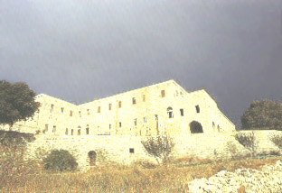
The Patriarchal See in Kfarhay from 687-938
Photo: The Maronite Patriarchate History and Mission
by M. Awit, 1996.
they were ambushed on the way and two of their leaders were killed. This was only one of many persecutions which forced John Maron to flee several times. He died c. 707 in Kfarhay near Batroun, Lebanon.
III. Contacts with Rome
While proud of their Eastern roots, the Maronites have seemed always to have a universalist attitude. Even in the earliest centuries, they did not hesitate to appeal to the Pope of Rome, as they did to report the massacre of the 350 Maronite monks in 517. A significant turn to the West occurred at the time of Crusades. Sharing the same faith as the Church of Rome, and not aligning themselves with the Church of Constantinople or the separated churches of the East, it was natural for them to turn to the West for support and to reinforce their independence. For this, they paid a price. Their Muslim rulers and Arab neighbors often questioned their allegiance to the Arab world, and at times considered them with suspicion as traitors. However, it would seem that the Maronites instinctively realized that their Christian faith should not be hemmed in by only one way of thinking or to an attitude that was closed to foreign ideas.
The first documented trip of a Maronite Patriarch to Rome was that of Jeremias El-Amsheeti (1199-1230). He participated at the Fourth Lateran Council in 1215. It is claimed that while he celebrated the Divine Qorbono in Rome a miracle took place. We are told by the 17th century patriarch and historian, Stephen Doueihi, that this miracle was celebrated by a painting depicting a consecrated host hovering over the head of the Patriarch. This painting was ordered restored by Pope Innocent X in 1655.
It was also during the reign of Patriarch Jeremias that Pope Innocent III addressed the Bull Quia Divinae Sapientiae to the Maronite Church. This major Papal document praised the Maronites for their faith, but also tried to urge them to adopt Latin customs in the liturgy and the sacraments.
Beginning in the middle of the 15th century communications and delegations between the Maronites and Rome began to occur on a regular basis. Patriarch Moses El-Akkari (1524-67) sent a bishop to represent him at the last session of the Council of Trent in 1562. In 1867, Patriarch Paul Mas’ad (1854-90) went to Rome to assist at the centenary feasts of Sts. Peter and Paul. He did not go to the First Vatican Council but was represented by a mission headed by Peter Bustany, Archbishop of Tyre and Sidon.
Patriarch Paul Meouchi (1955-75) and the Maronite bishops were active participants in the Second Vatican Council (1962-65). Since that time the visits of the Patriarchs to the Vatican have occurred on a regular basis.
A significant event for the Catholic Churches in Lebanon was the convening of the Special Assembly for Lebanon of the Synod of Bishops which was held at the Vatican from November 26 to December 14, 1995. Maronite Patriarch Nasrallah Sfeir was a co-president of the meetings. The Synod was seen as an opportunity for the six Catholic communities of Lebanon to seek spiritual renewal by rediscovering their religious roots, and implementing the teachings of the Second Vatican Council. Representatives of the non-Catholic Churches, the Protestants, Muslims and Druzes were invited observers.
From the 15th century on, the Popes have sent a number of Papal representatives to the Patriarchs. In the 16th and 17th centuries, Papal delegates presided at a number of special synods that dealt with issues of liturgy and pastoral practice. The work of these missions and synods culminated in the Synod of Mount Lebanon of 1736. It was approved by the Holy Father and became the particular law of the Maronite Church. In response to requests from a number of Patriarchs, the Papacy was instrumental in sending various religious orders to Lebanon. These religious communities were instrumental in establishing a large number of schools which resulted in Lebanon’s becoming the most literate country in the Middle East.
Relations between the Papacy and Lebanon were dramatically symbolized by the historic visit of Pope John Paul II to Lebanon in May, 1997. On that occasion he delivered his post-synodal exhortation, “A New Hope for Lebanon.”
IV. Persecution and Martyrdom
As already noted, as visible symbols of their people, many of the Maronite patriarchs were persecuted and sometimes martyred. This is why many of the patriarchal residences were located in places that were obscure and inaccessible. Whenever a Muslim ruler wished to punish the Maronites, the Patriarch was the one who was sought out. Also, there were times when Patriarchs were kidnapped and held for ransom as a means of extortion.
In order to avenge the raid of Pierre de Lusignan, King of Cyprus, on Alexandria, the Mameluk governor of Tripoli ordered the capture of Patriarch Gabriel of Hajjoula and had him burnt alive at the gates of the city in 1367.
Bishop Dib, cites a report sent from Qannoubin to the Pope in 1475 by the legate Brother Alexander of Arioste describing the situation in Lebanon at his time: “In the midst of this nation live the Saracens ... Their tyranny knows no rest. Under the pretext of raising a certain tribute that they call gelia, they [the agents of the authority] despoil the poor mountain people of all that they have. Against these vexations, there is only one recourse possible, apostasy. Many might have fallen if it had not been for the charity of their pious Patriarch [Peter Ibn Hassan] who came to their aid. Dismayed at the peril to the souls of his sheep, he gave over all the revenues of his churches to satisfy the greed of the tyrants. The door of the [patriarchal] monastery was walled up; sometimes he was obliged to hide in the caves hollowed out of the earth.”
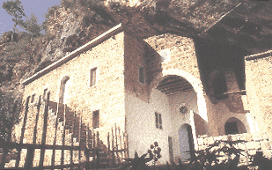
The Patriarchal See in Qannoubin from 1440-1823
Photo: The Maronite Patriarchate History and Mission
by M. Awit, 1996
In Lebanon in 1571 and again in c. 1634, there were severe persecutions by the Ottomans. The Turks looked upon submission to the Pope as to a foreign power. This was aggravated by the communications that the Maronites had established with Western European Catholic nations. The result was that when they were not undergoing persecutions, they were still subject to annoying harassments.
An eyewitness report about the precarious situation of the patriarchs is given by Chevalier d’Arvieux in the last part of the 17th century. He writes:
“He [the Patriarch] was hidden in a grotto far away, very secret, of difficult access and well covered, where he does not go out during the day but only at night. This is because the inhabitants of these mountains were at war with the Pasha of Tripoli, who had asked for a large sum of money which they judged was not proper to give him. The Pasha would often send the Turks to take the Patriarch and lead him to him, not doubting that when he would have him in his hands, all the Maronites would sell everything to ransom him from prison. ... Their [the patriarch and bishops] life was ordinarily extremely frugal; they fast often and very austerely; they work very hard and rise at night to chant the Office. ... They have crosses of wood, but they are bishops of gold.”
During his term as Patriarch, Stephen Doueihi (1670-1704), suffered many persecutions and had to flee to Kesrawan and to the Chouf. There are many who say that many miracles took place during his life and after his death.
V. The Patriarchs and Scholarship
The Patriarchs have not only taken the lead in religious administration and personal courage, but have also been dedicated to the intellectual life. Here are a few examples. Patriarch Joseph Habib al-Aqouri (1644-48) wrote a defense of the Gregorian calendar, a Syriac grammar with interpretation in Karshuni (or Garshuni, Arabic written with Syriac letters), various hymns in Arabic, and perhaps a tract on the primacy of the Roman Pontiff. Patriarch John Safrawi (1648-56) did a study of the Divine Office and prepared an edition of the Fenqitho (the Proper of fixed feasts) which was published in two volumes in 1656, 1666.
As a student in Rome and in his travels throughout the Middle East, the future Patriarch Stephen Doueihi (1670-1704) collected and consulted manuscripts regarding all areas of Oriental studies. Patriarch Doueihi wrote several volumes on the history and doctrinal fidelity of the Maronite Church. He also produced a chronology of the Maronite patriarchs. Because of the quality of his research and the scholarship of his writing, he is considered the “Father of Maronite History.” Patriarch Doueihi’s work, Lamp of the Sanctuary, provides a comprehensive and definitive commentary on the Maronite liturgy. He also wrote works on the sacraments and other aspects of theology.
Patriarch Joseph Estephan (1766-1793), besides being the author of liturgical hymns, took the initiative to establish the seminary of Ain Warqa. This national seminary became famous for its excellence in learning and produced many patriarchs and bishops. Among the many works of Patriarch Paul Mas’ad (1854-90) were: a refutation of the position taken by Melkite Patriarch Maximus Mazloom regarding the antiquity of the Maronite Church, a work on the procession of the Holy Spirit against the Orthodox position, and a treatise on the perpetual virginity of Mary.

VI. Patriarchal Leadership in Lebanon of the 19th and 20th centuries
Depending on the vagaries of Ottoman rule, Lebanon in the 19th century was an arena where its various religious communities were caught in constantly shifting alliances, and where foreign powers were interfering to advance their own particular agendas. In this chaotic condition, it became necessary for the Maronite patriarchs, not only to act as the religious and political heads of their people, but also on behalf of the nation. This new and larger role is already seen in the person of Patriarch John el-Hajj (1890-98). Trained in civil law, Father el-Hajj was chosen to be the Maronite judge in the Majlis (Supreme Judicial Tribunal) which was established in 1845 in response to the massacres of 1841 and 1845. The jurisdiction of the Majlis was not limited to judicial affairs, but extended to financial and administrative matters. Dismayed by the Christian massacres of 1860, Father Hajj drafted a report containing a detailed account of these evils and spread it throughout Europe, especially France. As a result, a conference was assembled in Paris, which decided upon intervention to help the victims and punish the perpetrators. In the meantime, there was an attempt in Beirut to draft a treaty between the Maronites and Druzes which would give Turkish authority the sole responsibility and exclude all foreign intervention. The historian, Bishop Dib, reports that despite extreme pressure to sign the pact, el-Hajj refused. Therefore, when this treaty was presented to the international commission, it was considered not binding, because it did not have the ratification of the Maronite judge. El-Hajj continued to manifest these qualities of leadership and courage as Patriarch.
Besides his extensive achievements in his religious role of Patriarch including the building of the Shrine of Our Lady of Harissa and in founding the Maronite Congregation of the Holy Family, Patriarch Elias Howayek (1899-1931) is in reality the father of modern Lebanon. He headed the Lebanese delegation to the Peace Conference of Versailles in 1919. The collapse of the Ottoman Empire had aroused various nationalistic ambitions in the Middle East and some attempts to compromise Lebanon’s sovereignty. The Lebanese national identity had existed for centuries. Throughout the succession of various Muslim rulers, the inhabitants of Mount Lebanon had struggled and been martyred to preserve who they are. After World War I, some elements were attempting to reconfigure Lebanon for their own dynastic and political purposes. Thanks to the prestige and courage of Patriarch Howayek, his proposals for a sovereign and independent Lebanon were accepted by the assembly at Versailles. Lebanon was granted independence under French mandate, with the restoration of its natural and historic borders.
The survival and evolution of the Republic of Lebanon has been a great challenge to its various religious constituencies. It is the only country in the Middle East where Christians have at least an equal role in the political, economic, and civic life of the country. Being a small country, Lebanon has always been affected by the interests of its larger and more powerful neighbors. Certainly, in recent years the Arab-Israeli conflicts have had a direct impact on Lebanon. The presence of several hundred thousand Palestinian refugees, a significant number of whom are armed, are a constant threat to the stability of the country, and were a prime factor in the hostilities of the 20 year conflict which began in 1975. The presence of several thousand Syrian and Israeli troops during this same period have had a chilling effect on the political and social life of the country.
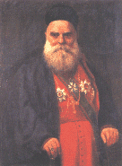
Patriarch Elias Howayek (1899-1931)
father of modern Lebanon.
Photo: The Maronite Patriarchate
History and Mission
by M. Awit, 1996.
In the midst of all these trying circumstances, there is the desire, expressed recently by the Special Synod for Lebanon and the Holy Father himself, that Christians and Muslims in Lebanon seek ways to build a country which is a true democracy where all religions and peoples are free to exercise their fundamental human rights on an equal footing.
The tragic events of the last 25 years have resulted in the assassination and exile of many political and civic leaders. This vacuum of leadership has required the Maronite patriarch to take on a national role, even larger than that of his immediate predecessors. Patriarch Nasrallah Sfeir (1986-) has fulfilled this challenge with a powerful eloquence and personal courage. He has become the conscience of the nation. At great personal risk, he has questioned the presence of foreign occupiers in the country. He has challenged the world community to guarantee Lebanon’s independence and restore its sovereignty. He has been the constant spokesman for the thousands who have been displaced because of the war, and for economic justice for the hundreds of thousands who have become impoverished. While especially concerned with the welfare of his people, Patriarch Sfeir has sought to solidify the bonds and increase relations with all the religious communities in Lebanon.
The history of the Maronite Church reveals both times of struggle and persecution, and periods of progress and glory. Its rich tradition and vibrant way of life is the result of 1500 years of labor, sagacity, and perseverance. The constant throughout its history has been the leadership of its Patriarchs, in all aspects of Maronite life. Now a world-wide Church, it faces the future with new threats to its survival, but with abundant internal resources and realistic confidence. It lives in the hope that God will continue to provide her with Patriarchs of stature and qualities able to meet and overcome the greatest of challenges.
____________________
This article is reprinted with permission from the “Maronite Voice”, Eparchy of Saint Maron USA, Special Issue Summer 2000, Volume 6.
For further reading on the subject, consult the following references: History of the Maronite Church, by P. Dib, translated by S. Beggiani, Diocese of Saint Maron: Detroit, 1971; Tarikh al Azminat, by I. Duwaihi, Edited by B. Fahd, Lahd Khater: Beirut, n.d.; The Power of the Patriarch - Patriarchal Jurisdiction on the Verge of the Third Millennium, by Rev. Francis John Marini, J.C.O.D., Maronite Rite Series Volume VI, 1998. The Maronite Patriarchate, by M. Awitt, Arab Printing Press: Lebanon, 1996; The Maronites, Roots and Identity, by W. P. Tayah, Florida: Beit Maroon, 1987.
The Role Of The Patriarch
Outside The Middle East
By Reverend Francis J. Marini, J.D., J.C.O.D.
Chancellor, Eparchy of Saint Maron of Brooklyn, New York.
I. Introduction
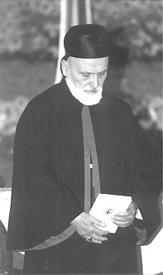
His Beatitude, Mar Nasrallah Boutros Cardinal Sfeir,
Maronite Patriarch of Antioch and All the East.
Every Maronite knows that the head of the universal Catholic Church is His Holiness, Pope John Paul II, Pope of Rome, and that the head of the Maronite Church is His Beatitude, Mar Nasrallah Boutros Cardinal Sfeir, Maronite Patriarch of Antioch and All the East. As Catholics and Maronites we honor and revere both the Pope and the Patriarch.
The authority and place of the Pope is well understood throughout the world, just as the authority and place of the Patriarch is in Lebanon. However, the role of the Patriarch is not nearly so clear, nor so well understood, when it comes to the situation of Maronites who are living outside of the Middle East, like us here in the United States.
II. The Figure of the Patriarch
According to the fathers of the Second Vatican Council, the Patriarch is the “Father and Head” of the Maronite Church. As Patriarch, he enjoys full power over all the Bishops and Faithful of the Maronite Church according to the norm of law approved by the Supreme Authority of the Church (the Pope or an Ecumenical Council acting together with the Pope). He represents in his person the entire Maronite Church, and he is the principal representative and spokesman for the Maronite Church and for all Maronites everywhere.
III. Synodal Governance
The authentic Eastern form of Church governance is synodal, not monarchical, so the Patriarch actually governs the Maronite Church together with the Synod of Bishops. The Patriarch exercises executive power and the Synod of Bishops exercises legislative power, similar to the American secular government. That is the reason that all the Maronite Bishops throughout the world gather at Bkerk? every June for the annual meeting of the Synod of Bishops. There, under the presidency of the Patriarch, all major decisions affecting the Maronite Church are discussed and made.
IV. Powers Inside/Outside Territory
However, the present Eastern Canon Law distinguishes between the powers of the Patriarch and Synod of Bishops inside the “Patriarchal Territory” and outside of it; and it expressly states that their powers are exercised validly only inside the Patriarchal Territory, with certain limited exceptions (CCEO Canons 78, § 2 and 150, §§2 and 3). The basic reality is that all laws enacted by the Synod and promulgated by the Patriarch are effective inside the Patriarchal Territory, but for us Maronites outside the territory, the only laws that are currently effective are Liturgical laws.
V. Historical overview
The reason for this distinction is that, from the very earliest times, Patriarchal power or jurisdiction has been subject to a geographical limitation. This restriction, known as the Patriarchal Territory, refers to those regions in which the proper rite of the Church is observed and in which the Patriarch has the right to establish ecclesiastical provinces, eparchies and exarchies (CCEO Canon 146, § 1). Only the Pope can change the Patriarchal Territory (CCEO Canon 146, § 2). The Patriarchal Territory of the Maronite Church is Lebanon, Syria, the Holy Land, the rest of the Middle East and Egypt.
The Patriarchal jurisdiction goes back to the very earliest times of the Church. This is clear from Canon 6 of the very first Ecumenical Council, Nicea ! (A.D. 325), which recognized the already-existing jurisdiction of Rome, Alexandria and Antioch, all based on a relationship to the Apostle Peter. This same canon was cited by the Second Vatican Council in its decision to restore the powers of the Eastern Patriarchs as existing in a special relationship to the Western Patriarchate headed by the Roman Pontiff who has primacy as the Successor of Peter (Decree on the Eastern Catholic Churches Orientalium Ecclesiarum N. 7, 1.) Throughout the first two millennia of Christianity, the Eastern Patriarchate and the concept or principle of territoriality evolved side-by-side in the Church. A similar evolution occurred in the territoriality principle. In the beginning, the concept was strict territoriality, however, it began to erode almost immediately. Lateran IV’s recognition of the right of Catholic faithful of different rites to pastoral care in their own liturgical tradition and church hastened the formation of Hierarchies for the various rites where faithful of different rites lived together. This in turn led directly to the practice of defining the jurisdiction of the Hierarchy by the double standard of territory and rite, resulting in the application of a principle, not of strict, but of qualified territoriality. The fathers of Vatican II, the heirs of these developments, adopted the Principle of Qualified Territoriality as the norm (Vatican II, Decree on the Pastoral Office of Bishops in the Church Christus Dominus N. 23, 3), 2). Thus, both territory and membership in a particular Church sui iuris control in both the Latin and Eastern Churches, as is clear even within the Patriarchal Territories, since all of the Eastern Patriarchates overlap to some extent in the Middle East.
VI. The Future
It is true that the authentic Eastern tradition requires a Patriarchal Territory, but it is certainly also true that there is nothing to prevent the expansion of the present Patriarchal Territory or of the jurisdiction of the Patriarch and Synod of Bishops outside the Patriarchal Territory. The Maronite Patriarchal Territory was already extended in 1741 by Pope Benedict XIV, and the Melkite Patriarchal Territory was extended in 1894 by Pope Leo XIII. Recent statements from the Vatican indicate that both expansion of the jurisdiction outside the territory and expansion of the territory itself are open possibilities. Thus, the idea of expanding the Patriarchal Territory to include all erected eparchies wherever they may be, which would include the Eparchy of Saint Maron of Brooklyn and the Eparchy of Our Lady of Lebanon of Los Angeles, is certainly viable.
It is necessary for the survival and growth of the Maronite Church to more fully implement the rich image of the Patriarch as “Father and Head” of our Maronite Church. At the present time, Maronite faithful living outside of the Middle East are more like stepchildren than children of the Patriarch. To remedy this situation requires the normalization of our relationship to our Father and Head, by preserving our authentic tradition while adapting to a changed and changing world.
This article is reprinted with permission from the “Maronite Voice”, Eparchy of Saint Maron USA, Special Issue Summer 2000, Volume 6.
Code of Canons of the Eastern Churches: A Latin-English edition of the Codex Canonum Ecclesiarum Orientalium; published by the Canon Law Society of America, 1992; Eastern Catholic Churches: Constitution and Governance by John D. Faris, 1992; The Power of the Patriarch - Patriarchal Jurisdiction on the Verge of the Third Millennium, by Rev. Francis John Marini, J.C.O.D., Maronite Rite Series Volume VI, 1998.

A FIRST READING OF THE NEWLY DISCOVERED ODE
TO SAINT MARINA, THE MONK
By Guita G. Hourani
Chairperson of MARI
This third article on Saint Marina the Monk deals with the author's discovery of an ode in honor of the Saint written in Garshuni (Arabic written in Syriac script). The first article or Part I narrated the Saint’s biography according to the Maronite tradition, gave an overview of the most important references to her, related the legends surrounding her relics, and described her Sacred Office (the daily schedule of prayers). The second article or Part II focused on Saint Marina’s churches, sanctuaries, those especially devoted to her, and her iconography in Lebanon and Cyprus. The author thanks Mr. Moses Karkanny for his assistance in transliterating the ode from Garshuni into Arabic.
I. HOW THE ODE WAS DISCOVERED
The ode in Garshuni to Saint Marina is published here for the first time. It is a newly discovered manuscript, found by the author in the summer of 1999. The author was visiting Our Lady of Qannoubin Monastery for a day of recollection with the Antonine nuns who are currently the caretakers of the Monastery. Leafing through a Bible written in Garshuni before she went to sleep, she found the almost unrecognized two-page leaflet tucked among the thick pages.
Early the next day, she headed back to Beirut for a morning meeting. Despite uncertainties about the manuscript she was carrying, she felt that finding the ode while she was writing the biography of the Saint was Divine Providence, and not coincidence.
II. THE MANUSCRIPT
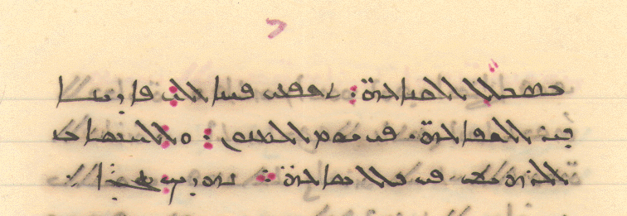 | 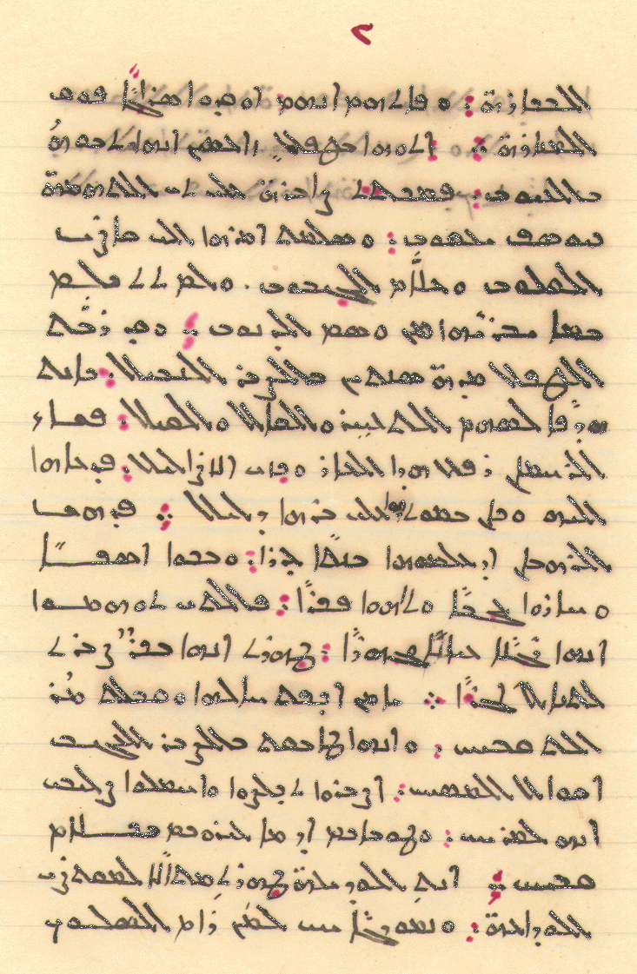 | 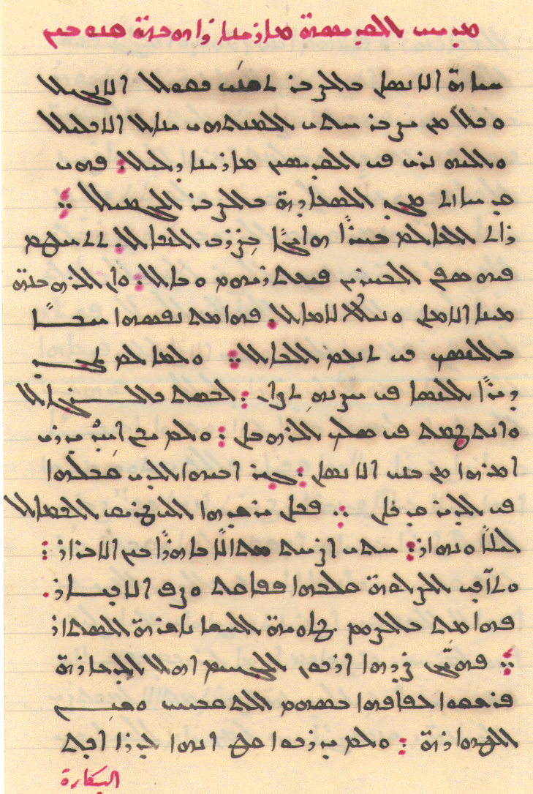
The Monastery of Our Lady of Qannoubin[i]and the grotto which still carries the name of Marina were the setting for the passion and sainthood of this maiden. [ii] This ode in homage to Marina gives a brief account of her life.

The ode is cursive, having been written with black and red Chinese ink and using an old-fashioned feather quill and ink well. The ode is written in the Estrangelo Syriac calligraphy. It is written on an ecru double sheet of lined paper 4.3 inches wide and 6.7 inches long. Each page has 19 lines on which the poet wrote his composition. The penmanship is superb. The manuscript is in a very good condition and has not been altered.
The first page begins with the title of the ode written in red ink and reads as follows: “Ode for Saint Marina the Woman Monk of Qannoubin.” Following the title are 18 lines of verse written in black ink with red punctuation. The last verse on this page is “They did not know at all that she is a virgin”. The first page ends with the first word from the second page, pursuant to the Syriac tradition in writing; however the word is written in Arabic instead of Garshuni.
The second page is kept blank. The third page contains the succeeding verses and is numbered in Arabic. Similarly, the poet used the 19 lines of the page to write his poetry but did not include the first word of the fourth page at the end of the verses. The last sentence on this page reads: “And was a living example for those who seek to embark…”
The fourth and last page has only three verses and ends with the words: “Intercede with the best of intercessions to our Savior for us on the day of our death, and in every hour of Judgment Day.” The poet closes the ode by offering it to Saint Marina, saying: “We offer you this in glory”.

Although the ode is written as prose, it is actually a poem of 10 strophes. Each strophe is composed of two verses and ends with two successive black periods and two superimposed red dots. Each verse is written in two hemistiches. Each four hemistiches have the same rhyme. Every hemistich ends with two periods, one in black ink and one in red. Each verse ends with three superimposed periods, one in black in the middle and two in red above and blow.
The language of the poem is mostly literary Arabic mixed with some colloquial Lebanese Arabic. The poet suppresses the accent-vowels to maintain the rhyme and the measure of the verse just as occurs in poems in the vernacular of all countries.
The main discrepancy in the narrative, as told by the poet of this ode, is that Marina went to Qannoubin because she did not find a women’s convent to join. Most accounts assert that she actually wanted to be with her father; hence, she had to disguise herself as a man to enter the monastery.
The manuscript may date from the 1800s or early 1900s because Garshuni was no longer used after that and the Monastery of Qannoubin -- where the manuscript was found -- was abandoned for the newly built summer Patriarchal residence of Our Lady of Diman in 1823.
III. THE POET OF THE ODE
The poet did not autograph the poem. Nevertheless, the ode gives clues which could be helpful in identifying the poet. The beautiful, steady handwritten Syriac script shows the poet’s fine grasp of Syriac calligraphy and style. He must have been an educated clergyman, possibly a scribe. When the Monastery of Qannoubin was the Patriarchal See, it was vibrant with the presence of so many clergy and prelates.
Because the word “patience” appears more than eight times and because of the repeated praise of monastic life, one may make some assumptions. Perhaps, the poet of the Ode to Saint Marina was a monk or a hermit who composed it and placed it in the Bible which he used each day when celebrating the Liturgy.
IV. THE TRANSLATION OF THE MANUSCRIPT
Some of the punctuation used in the manuscript can not be duplicated. Instead, each strophe is numbered and ends with similar punctuation to facilitate the comparison between the manuscript and (between) the translation and the development of the poet’s composition.
Ode to Saint Marina, the Woman Monk of Qannoubin
1.The life of man in patience is gained as the Bible says.
And everyone who is patient until the end is given the crown.
Hence we see in Saint Marina a proof.
She has gained the glory of joy through grace-filled patience*
2.She saw the world as a heaving sea of punishment,
With the seafarers shipwrecked, overcome by evil consequences.
And that the monastic life[iii] is the safe port and the achiever of hopes.
Her spirit became captivated with love for the life of a hermit to calm the mind*
3.When she did not find a convent for women to live chastely within its cloister,
She dressed as a man and joined the monks.
No one of the human race knew about her.
Except her father who accepted her in the monastery where he was*
4.He was guiding her to the way of perfection day and night,
Until she became a shining example among the righteous.
Prayers became her heart’s companions so she surpassed the quality of the elites
She became enchanted with fasting and concealed her abstinence*
5.Hell’s notables roused the people against her for immorality,
Who with the arrows of disgrace thrown at her purity and the marring of purity.
They did not know at all that she is a virgin.
They knew that they had discovered a candle lit above the lighthouse*[iv]
6.They brought her a baby remarking that he was born through disgrace.
She sustained these accusations with the patience of Joseph Jacob [Job].
She appealed her case to the Judge of Hearts and to He Who Knows the Invisible.
She did not speak that which would exonerate her from the stigma of guilt*

7.She raised the baby for two years with noblest patience,
While she was a target of the arrows of reproach and gossip.
But the Merciful One willed to alleviate this shame and to defeat these deceits.
He called her to Him and in her death was the evidence of her righteousness*
8.The monks were astonished when they knew that she was a maiden.
They wept in regret, they were amazed, and were bewildered [but] with pride.
For she, the one they thought to be clearly and publicly a man,
Was revealed a virgin who was patient in order to win the reward*
9.She disguised herself and accepted the bitterest of insults.
She applied the teachings of Christ with incredible patience.
Be patient and you will be saved, carry My cross it is very comforting.
Blessed are you if you were rebuked with vile words*
10.You meek [Marina], you brightly shined as the model of humility.
And you were a living example for those who seek to embark on the road of contentment.
Intercede, by the best of intercessions, for us with our Savior on the day of our death,
And during every hour of the Judgment Day*
We offer you this in glory.
V. CONCLUSION
Carbon dating of the paper and other thorough analyses are needed to date the manuscript and learn more about it and its poet.
The author of this article believes that this manuscript and other similar discoveries are part of the collective heritage. She decided, now that the ode has been made public, to send the original manuscript to the Maronite Patriarchal Archive in Bkerke where it will be safe and made available to other researchers.

[i]The Monastery was the Patriarchal See from 1445 to 1823.
[ii] Marina was disguised as a man in order to join her father in the monastery. She was later accused of fathering a child. She did not defend herself from the crime she was accused of, but with humility accepted the severe punishment that was pronounced against her by the Abbot: to leave the monastery and to raise the child. She spent the rest of her life living ascetically and looking after the child. Her identity as a woman was only revealed after her death. Léon Clugnet states that the confusion pertaining to all of the other saints named Marina is due to the translators and the copyists' attribution of the saint's origins to their own countries or other countries that they felt better fit the Saint's life. This is why we find that the Greek version of Saint Marina's life places her birth in Bethany; the Coptic version in Egypt and some of the Latin places it in Italy (Clugnet 1904: 265 footnote # 2). According to the most ancient accounts on Saint Marina the Monk, only one place of origin could be hers -- Lebanon. Clugnet resolves that until new discoveries are made, the only origin of Saint Marina must be the one known to us according to tradition and since the only tradition about this Saint is found among the Maronites of Lebanon, then Lebanon is to be considered the land of her birth (Clugnet 1904: 565). The Maronites resolutely believe that Marina originated in Lebanon and that as a monk she has lived and died in the Monastery of Qannoubin in the Holy Valley of Qadisha. J. Fiey in turn concludes that Marina in question is truly a local saint of Lebanon, victim of imposture (Fiey 1978: 33).
For the complete hagiography of the Saint see http://www.mari.org/JMS/january00/Saint_Marina_the_Monk.htm] and for information about her iconography, relics, and churches see [http://www.mari.org/JMS/july00/Saint_Marina_The_Monk.htm]

[iii] The author uses the word “Rahbaneh” in Arabic which means monastic order.
[iv]The lighthouse is the Monastery of Qannoubin which was known as a place of piety and reverence.

MARI AT THE SIXTY-SEVENTH CONVENTION
OF THE ASSYRIAN AMERICAN NATIONAL FEDERATION
CHICAGO, AUGUST 31 - SEPTEMBER 4, 2000
The sixty-seventh Convention of the Assyrian American National Federation (AANF) was held in Chicago, Illinois, from August 31 to September 4, 2000. Ms. Guita Hourani, Chairwoman of the Maronite Research Institute (MARI), addressed the conventioneers. She spoke about cultural activism and the role of the individual and the community in preserving and advancing the Syriac tradition.
AANF is a federation of Assyrian associations in the United States. It was founded in 1933 following the massacres of the Assyrians in Iraq.
The Assyrians are the descendants of the inhabitants of ancient Assyria. This nation was a dependency of Babylon at first but soon became an independent state by the 14th century BC. Assyria developed into a mighty kingdom encompassing a great part of the lands now known as Iraq, Iran, Syria, and Turkey. Throughout its history, Assyria was led by great leaders of whom the most prominent and famous are Tiglath-pileser III, Sargon II, Sennacherib, and Esarhaddon. This grand civilization was characterized by its monumental structures, now seen in the ruins of Nineveh, Ashur, and Nimrud.[i]
The Assyrians were among the first to believe in Christ as the Messiah. After their conversion, they eagerly took the call into the very heartland of the Far East. There they spread the Good News and the language, Syriac, made holy by Him Who spoke it -- Christ, the Son of God made Man.
Since the fall of the Assyrian empire, they have suffered because of their race; and since becoming Christians early in our era, they have endured because or their faith. The massacres of the first part of the 20th century caused the exodus of most of the Assyrians from the Middle East to Europe, the United States of America, and Australia. This race, whose homeland was once a cradle of civilization and a rival of other ancient empires, is a now another people in the Diaspora.
The Convention brings Assyrians together to share their current and future concerns, a collective memory, and past glory. Like all people of ancient cultures, they are threatened by complete assimilation within their newly adopted societies. Yet, they make a conscious effort to protect and pass their culture on to their offspring. It was in this spirit that Ms. Hourani spoke about preserving and rejuvenating their culture and sharing it with others.
On the level of the individual, Ms. Hourani talked about sharing one’s own tradition with friends, colleagues, and acquaintances through dinner parties, poetry reading, music performances; gift giving of books, videos, compact disks to ones local library, Alma Mater, political representatives, and friends. Get actively involved in writing a family history, collecting and preserving family and community memorabilia; participating in cultural activities in ones neighborhood or city by presenting movies, theater and music performances, art exhibits, and story telling. Give local lectures about the tradition at schools, organizations, libraries, and churches. Generously invite others to celebrate special feast days and share in special occasions and celebrations. Invite and support students and researchers to live in the community and study it. Read and learn more about ones tradition. Get ones children interested in their culture and have them invite their friends for a fun and interesting evening centered around something that is uniquely Assyrian. Movie nights featuring culture and history at ones home occasionally are a pleasure to be enjoyed with invited friends, family members, and school or work colleagues. Concentrate on exposing ones children, cousins, nephews and nieces to the tradition.
On the community level, Ms. Hourani encouraged the participation in international festivals, state and federal cultural and educational activities. Have an open house at the church or one of the organizations where people will learn more about the culture and have a refreshment. Publish written articles locally and beyond. Utilize local radio and TV programs to inform and educate the public.
Support efforts to record oral history and the making of documentaries of the community in the U.S. and in the native land. Put on productions, theater, musicals, concerts, and exhibits that promulgate the culture. Sponsor a joint event with other minorities or peoples of ancient cultures. Invite and pay the expenses for a famous or prominent member of the media to visit your homeland to write about the plight of your people. Have church choirs participate in the all the public celebration of Christmas.
Create summer studies programs in the Middle East for teenagers with modules on the history, geography, literature. This will encourage ties between these young people and other members of your community in the Middle East. Cooperate with the local historical societies and federal agencies like the Smithsonian Institution and the Library of Congress which are involved in these pursuits in preserving, recording and retelling the history, lore and cultural achievements cultures found in America.
Ms. Hourani stressed the fact that sometimes a community either assimilates into or isolates itself from the larger society. Either one would be detrimental to the preservation and promulgation of ones culture. She believes that sometimes people impose a self isolation on themselves, and prevent others from knowing them, sharing their joys and sorrows, understanding them, and appreciating the wonderful experiences and enlightenment that spring from their heritage. “How can we expect people to know us if we do not tell them who we are; if we don't invite them to our homes, churches, organizations, to intermingle culturally with neighboring communities? Can we expect them to support our causes and sympathize with us if they don't know us?" Ms. Hourani asked.
She observed many positive elements in the convention. They include:
  - The continued use of the Assyrian language by the Assyrian American people.
  - The exclusive use of Assyrian music and songs throughout the convention.
  - The invitation and encouragement of young graduates to present their research findings or socio-political experience.
  - The sense of collective pride.
  - The recording of Assyrian music, songs, and poems in Compact Disks and the promotion of Assyrian art, especially the reproduction and reinterpretation of ancient art.
  - The founding of several endowments to promote education, researches and lectures on Assyria and the Assyrian people. Endowments such as The George Mardinly Educational Fund in New Jersey, The David B. Perley Memorial Assyrian Fund and the Mishael and Lillie Naby Assyrian Lecture Fund at Harvard University, and The Naoum Faik Assyrian Book Fund at Columbia University are some of them.
Ms. Hourani observed that the Assyrian people live in a real Diaspora in the hope that one day they will regain their ancestral land and revive their culture.
She was deeply affected by the wholehearted and warm welcome that she received. She was overwhelmed by the respect, admiration, and love that the Assyrian people have for Lebanon in general and the Maronites in particular.
MARI and Ms. Hourani hope that this invitation will only be the first step toward a deeper intellectual, academic, and cultural cooperation between MARI and the Assyrian organizations in the United States.
LEBANON, A 10-DAY FAMILY VISIT
By Eddie Daniel.
He was born and raised in Mannington, West Virginia, the youngest child of Pete and Hasiba (née Raad) Daniel, and is now retired.
In this section of the Journal of Maronite Studies (JMS), we bring you travel accounts of past or current travelers who have written about the Maronites and Lebanon. These accounts are unedited and represent the views of their author(s).
In 1904, a 14 year-old Lebanese boy named Peter Daniel, left his mountain village of Beit Meri and made his way down the steep, winding road to the seaport of Beirut. From there, he departed on a long journey that eventually brought him to the shores of the United States. From there he followed the route taken by earlier Lebanese immigrants to reach the oil-boom town of Mannington, West Virginia, located in the foothills of the Allegheny Mountains. To this day, a large part of his descendants still live there.
He made the journey alone, leaving behind his mother, father, three brothers and two sisters. A journey, which took him weeks to complete in 1904, was made in a matter of hours by his youngest son, Eddie, and his oldest son, Donald, in September 2000. They traveled back to the land of their ancestry -- 96 years later! And what a trip it was. It was the trip of a lifetime!
It had been almost 20 years since I last had contact with any of my relatives in Lebanon. By learning how to access the Internet and locating a program called the “Lebanese White Pages”, I eventually was able to make contact with Tony Daniel, a son of my first cousin, Ramez Daniel. Through almost daily e-mail contact and a couple of telephone calls back and forth, Donald and I were invited to visit our cousin Ramez and his family. Thus began our 10-day adventure in the land of our ancestry -- Lebanon.
While Ramez’s apartment was to be our home for the next 10 days, Farouk, the owner of a taxi service in Beit Meri, was to be our chauffeur and guide during our stay. If you have never been to Lebanon, you cannot imagine the crazy driving and drivers that haunt the highways, byways and downtown areas of the cities and villages. They are reckless to say the least. and the most reckless and fearless is my cousin Farouk. I shall forever call him “Fearless Farouk”. He fears no man, no car, no truck, no soldier, no police officer, no road! And his skills as a driver cannot be disputed. He makes his living by driving and he does it well, even though reckless!
We arrived at Beirut Airport on September 14 and were met by the entire families of Ramez and his brother, Farouk, all ten of them. They included Ramez’s wife Mary, sons Tony and Dany and daughter, Desiree, along with Farouk’s wife, Violet, and daughters Sabine and Nicole and son, Mario. We were whisked to the apartment of Ramez in Mansorieh El Matn, just north of Beirut on the mountain road to Beit Meri. There we feasted on traditional Lebanese foods and the national drink called Arak – a drink made from fermented grapes and anise. It is one of my favorite alcoholic drinks, one we were to indulge in at almost each meal. If you don’t drink Arak , you’re not a true Lebanese!
Ramez’s apartment was to be our home for the entire stay in Lebanon, a home filled with hospitality and warmth. Some of our most memorable moments in Lebanon were spent there. Ramez, his wife and children made us feel very welcome. Better hosts cannot be found anywhere.
While Ramez’s apartment was to be our home for the next ten days, Farouk, the owner of a taxi service in Beit Meri, was to be our chauffeur and guide during our stay. If you have never been to Lebanon, you cannot imagine the crazy driving and drivers that haunt the highways, byways and downtown areas of the cities and villages. They are reckless to say the least and the most reckless and fearless is my cousin Farouk. I shall forever call him “Fearless Farouk”. He fears no man, no car, no truck, no soldier, no police officer, no road! And his skills as a driver cannot be disputed. He makes his living by driving and he does it well, even though reckless!
On the evening of our first day in Lebanon, September 14, was the celebration of “Eid el Salib” (Feast of the Cross). The next day was the feast day of Saint Sassine, the patron saint of the village of Beit Meri and the saint after whom the church is named. On each day, the streets were filled with throngs of people, all kinds of food, souvenir and gift booths, and craft shops. It was a very festive occasion and reminded me of a state fair in the United States, only with strong religious overtones. The church bells were constantly being rung by the men and boys of the village, each trying to outdo the other. The church itself was constantly filled with worshippers.
There is a plaza behind the church and it was there that we were to meet a first cousin whom we had never met before. His name is Elias Daniel and he is the son of my Aunt Mariam Daniel and Toufic Daniel. Let me explain how a Daniel marrying a Daniel came about. My Uncle Bill Daniel, who lived in Wheeling, West Virginia, related the story to me.
Elias’ father, Toufic Daniel, eloped and married his cousin Mariam, who is my aunt. However, my grandmother Yasmine had forbidden her daughter, my aunt Mariam, to marry Toufic because he was her first cousin. Toufic, not one to take “No” for an answer, gathered a group of armed young men, loaded them on a flat-bed wagon, went to my grandmother’s house and kidnapped my Aunt Mariam who was in agreement. He, along with the other young men, went to a neighboring village and forced the parish priest to marry them. The marriage proved to be successful since they brought forth six children, all who are normal and healthy. Toufic Daniel and Aunt Mariam lived a happy life together.
Elias still lives in the original Daniel home in Beit Meri. It is the home in which my grandfather, Daniel Daniel, was born and raised. It is built upon the side of the mountain and has terraced vegetable gardens. There is a stone step-way leading down to the house from the upper road and winds all the way down to the next road below. Growing along the steps are prickly pear cacti. They have been there for several years since I can remember my father telling me about them and how good they were. Seeing this home and being able to tour it was one of the highlights of the Lebanon trip.
Early Friday morning, “Fearless Farouk” was at the apartment waiting to take us on a daylong trip of visiting relatives. These were the Raads and the Daniels, who live in Beit Meri. It was to be a whirlwind tour.
The first person we visited was Najem Madi, my first cousin on my mother’s side of the family. His mother and my mother were sisters, both from the Raad family. Najem lives in the old Raad home. Upon our arrival, his wife Linda and his niece, Teresa greeted us. Within minutes, the house was filled with relatives, all wanting the chance to meet their American cousins. How they all found out we were there is still a mystery to me. The house is one of the older-style homes we visited. It has a very unique and unusual ceiling which I had never seen before. It is covered with small tree limbs across which are braces of larger logs of tree trunks. To replicate a ceiling like this in the United States would cost several hundreds of dollars.
We spent about an hour visiting with our relatives and taking pictures and being invited to return the next week for a family dinner. We gladly accepted since it would give us the opportunity to spend more time with them and also meet other members of the family. Then, we were on our way to visit more “cousins”. Everyone we visited that day, whether Raad or Daniel, insisted on having us for lunch or dinner. This hospitality was to be extended to us each day of our stay in Lebanon and by everyone we visited.
One of the next stops we made that day was at the variety store owned by my cousin, Joseph Raad, who also happens to be the mayor of Beit Meri. Joe had been to Mannington on two or three occasions when he had visited his Aunt Labibe Raad Francis, who lived on the next block from my house. One of the visits was made as part of his honeymoon trip. He and I got to spend quite a bit of time together on his visits to the U.S. and the Daniel family sort of adopted him as one of ours. He invited Donald and me to dinner at a restaurant owned by his brother-in-law. It was quaint and charming with an outdoor dining room and in the distance could be seen the city of Beirut. We were joined by his first cousin, Claude Raad, who is related to me on both sides of the family. It was an evening filled with laughter and joy. Old memories were revived and new memories made.
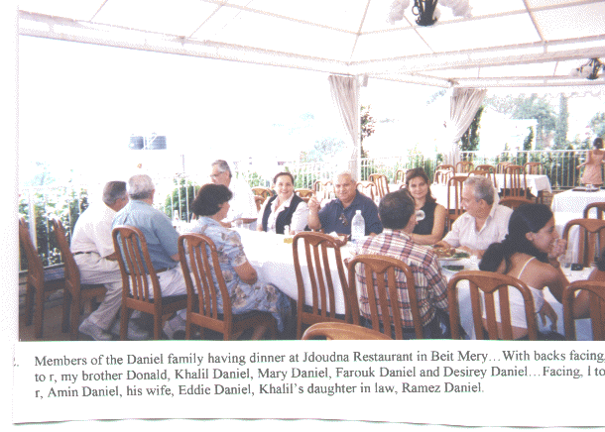
On Saturday, we were invited to have lunch at one of Beit Meri’s famous restaurants, I believe the name was “Jdoudna” (“Our Grandparents”). Our host for that day was Khalil Daniel and his wife, Hoda. Kay [Khalil] is a fourth cousin who had made several trips to Mannington in the late 1950’s and 1960’s, visiting his Aunt Matilda Daniel Simon. Not only did he host Donald and me, but the entire Ramez and Farouk families, his brother, Amin and wife and his daughter-in-law. The food and service, as usual in Lebanese restaurants of this caliber, were excellent and a good time was had by all.
On Sunday we attended Mass at Mar (Saint) Sassine’s Church. This is the church where my mother and father were married. It’s a typical Lebanese-Maronite style church in structure, with massive stone walls. The interior was not lavish as, for example, in a baroque-style church. It was beautiful in its simplicity of décor. Just to be here took me back in time to when my parents and all of my other ancestors came here to celebrate Mass and all the Holy Days of Obligation, to be baptized, to be married and to be buried. I was overcome with emotions that I trembled. My heart quivered and the hairs on my body stood up. It was an awe-inspiring moment which my body absorbed like a sponge drawing in water.
After Mass, I asked about the location of the Raad and Daniel families' crypts. Outside the church at the end of the plaza, there is a gate which leads down a small flight of steps to the walkway along which the crypts were located. Not being able to read the inscriptions in Arabic, I was told which crypts were for the Raad and Daniel families. I was taken aback when I discovered that, unlike the entrance to the other vaults, the Daniel crypt had a locked, steel gate barring the entrance. I jokingly said this could only have been to make sure the Daniels did not try to leave after being interred.
After taking pictures of the crypts, my cousin “Fearless Farouk” took us to the top of the mountain beyond the church, to see the ruins of a 5th century Byzantine church. Also nearby are the ruins of a Roman temple, which was probably built atop more ancient Phoenician ruins. From this point, one could look across miles and miles of mountains. To get there, one has to pass a Syrian military outpost. This didn’t seem to bother my cousin but I felt a little uneasy. When we were walking around the ruins taking pictures, a Syrian soldier came near, probably wanting to see what we were doing there. Instead of showing him fear, I used the old, friendly West Virginia
hillbilly sign of peace, a wave of the hand and he, in turn, placed his hand over his heart and bowed towards me. I was told that this was his way of giving me a peace symbol. All’s well that ends well.
Nearing lunchtime, we returned to Farouk’s house, where his wife had invited us to eat. Also there, was my cousin Ramez, his wife, Mary and their three children, along with a couple of friends of Violet’s. Lunch to the Lebanese is not what lunch is to an American. Arrayed on the table were all the mezze (Lebanese appetizers) dishes one could think of. By the time the main course arrived --kibbie, chicken, stuffed grape leaves, and, believe it or not, pizza and French fries-- we were almost too full to eat. I said almost too full. We went ahead and enjoyed the delicious food anyway and drank our share of Arak, to boot. Violet, who could not speak English, was a good cook. In order to communicate with her, we had to use our broken Arabic. By the end of our stay in Lebanon, we were beginning to speak Arabic quite well. My brother became better than I.
We spent Sunday evening back at Ramez’s apartment, our home away from home. Once again we were treated to another delicious meal, this one prepared by Mary. If I remember correctly, I believe that Mary’s mother and father, Elias and Loudy Saab, were also there. Even though they were not related to me, they were to become two of my favorite people. I always enjoyed their company. We were guests at their apartment in Beirut one evening the following week. They suffered a great tragedy during the war when their only son, Tony, a member of the Christian Resistance, was shot and killed while defending his homeland. He was one of the true martyrs of Lebanon.
Early Monday morning, “Fearless Farouk” was at the apartment to take us, his own children and Ramez and his entire family -- two carloads -- to Zahle and then to Baalbek. We were invited to the home of Farid Charbel in Zahle. Farid’s father and my father were half-brothers. My grandmother Yasmine Daniel was first married to a Charbel from near Zahle. She had one son, George, and a daughter, Philemena, by him.
My grandmother’s first husband and his family had been feuding with a Druze family. The Druze and the Maronites have had their share of animosity in the 19th and 20th centuries although they were allies earlier, especially during the Maan and the Chehab Principalities. The disputed ownership of a water well, along with religion, played a role in this feud. There were killings and revenge killings over the years. That part of Lebanon is known for its vendettas. Grandmother’s first husband was killed by members of the Druze family while drawing water from his well. My grandmother left the area afterwards, she took the her son and daughter to Zahle to be with their paternal grandparents. She moved back to her native village of Beit Meri where, later on, she met and eventually married my grandfather, Daniel Daniel.
My father and Farid Charbel’s father, half-brothers, were very close. My father was the oldest child from the second marriage and close to George in age. When my father was alive, he communicated with the Charbel family on a regular basis. Once they heard we were visiting Lebanon, they phoned and invited us for dinner.
What a trip it was from Beit Meri to Zahle. My cousin the taxi-driver, “Fearless Farouk”, wanted to take a short cut. The road was one that wound up and down and around the mountains leading to Zahle. It was mostly a one-way road and not in too good condition. We were at a high altitude, probably around 4,000 to 5,000 feet, and there were no guardrails. I was riding in the front passenger side of the car and could look down over the steep embankment alongside the road. Being afraid of heights, I was scared to death. To make matters worse, my cousin drove at his normal rate of speed, between 70 to 80 miles an hour, or so it seemed. A cement truck was speeding toward us and my heart was going even faster than the vehicles. I could see my final days on earth coming to an end. Do you think my cousin would slow down or yield? Not “Fearless Farouk”! He kept heading toward the truck like a bullet from a rifle barrel, thereby forcing the truck
driver to yield and issue forth profanities I will not repeat in writing. “Fearless Farouk” just grinned. When answering my question as to why he did not slow down or yield to a much larger vehicle, he asked me if I would like to drive instead of him. Thinking it over very quickly, I answered, “No Way”!
The road was worth putting up with because the most splendid sights began to unfurl before our eyes. Looking out over the mountains, one could see the Bekaa Valley far away. It was a little hazy that day, but still clear enough to take some pictures. The scenery in Lebanon is something you have to see to appreciate. It is a little hard to describe. For example, you may be driving along dusty, dirt- and rock-covered mountains one moment and the next you may be entering a fertile, tree-covered valley with apple, fig and pear trees and grape vines loaded to the hilt with their fruits. Beautiful!
On the way were several fruit and vegetable stands near the tops of the mountains, with only a house or two nearby. Beside one stand was an outdoor oven (furn) where they were making the paper-thin, flat Lebanese bread called Markouk . The women would toss the dough in the air, much like a pizza maker, until it became very thin. Then they would place it over the top of the dome of the oven. Within seconds the bread would be done. Delicious, especially when used as a wrap around shish kabobs, kafta, and vegetables. Also, the Markouk is good in it’s dried state as an important ingredient in the famous Lebanese fatoosh salad. We bought several loaves and snacked on them on the way.
Coming down the mountain to the city of Zahle was a sight to behold. Suddenly it appears before your eyes with its modern buildings intermingling with its more ancient buildings. Here is a Christian city located, basically, in a majority Moslem area, at the gateway to the Bekaa Valley and en route to Baalbek.

It is a resort city with many fine, open-air restaurants and hotels along the two main streets, Rue Brazil and Rue Saint Barbara. These two streets form a figure 8, much like the 8 formed by ice-skaters. In between are areas I shall call town squares and along them are various shops and commercial enterprises.

Our cousin Farid and his family live in the city in one of the traditional Lebanese-style homes. They are constructed from solid stone on the outside, with steps and floors made of either cut stone or marble. Farid and his wife, Elene, greeted us warmly at the door, and, after several hugs and kisses, we were escorted into one of many living rooms. As is typical, the coffee tables were laid out with packs of cigarettes. Most Lebanese men and women smoke, although I did not notice any of the teenagers smoking.

The daughter, Josephine, was assisting her mother, Elene, prepare the food. We waited for two of Farid’s sons, Joseph and Tony, who were to join us for dinner. Later before leaving Zahle, we met another son, Michael, who had been working and unable to be with us earlier.
When we were escorted into the dining room, I couldn’t believe my eyes when I saw all the mezze dishes I could imagine. Afterwards while visiting and chatting, nargeles (water pipes) were brought in. Farid is an avid narghele smoker and is shown with one in the picture of him and his wife. Stories were told of the family and how it came to settle in Zahle to escape the feuding that was going on in his birth village.
After the customary Turkish coffee and our final good-byes, we went on to the ancient ruins of the city of Baalbek. The drive from Zahle to Baalbek was like going from the 20th century to ancient times. For an American, it was a little nerve-wracking since we were now entering Hezbollah country. This is the area of Lebanon that was and is still controlled by the Hezbollah forces (a radical Shiite Moslem sect with strong ties to Syria and Iran). Along the road, the Hezbollah flag is
seen flying from telephone poles, rooftops and shops. This is the area of greatest anti-American sentiment, at least in years gone by, and even now, to a lesser extent. However, we entered the area with little fear of being harassed or otherwise bothered. As a matter of fact, tourism is now being sought and westerners are accepted. One can now get alcoholic beverages to drink in some of the restaurants and stores, after having once been prohibited by the Shiites, since it is against their religious beliefs to consume alcohol.
Also heartwarming, was the sight of checkpoints being manned by Lebanese Army units instead of Hezbollah guerrillas. The emblem of the cedar tree on the uniforms made one, especially an American, feel much safer and more at ease.
Before entering the area of the ruins, we stopped at a gift shop. I did have my picture taken in Bedouin garb. I looked authentic.
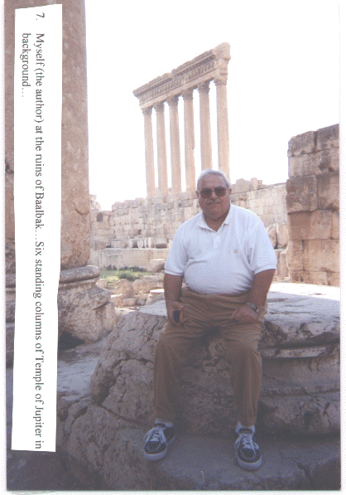
From there we went directly to the entrance to the ruins and what a sight it was. The ruins are the largest to be found in the Middle East and even rival those found in Rome. The temples, columns, arches, and carvings are awesome. Baalbek was originally a Phoenician temple dedicated to the god, Baal, hence its name. It was called Heliopolis (City of the Sun) by the Greek conqueror, Alexander the Great. That name was kept even by the Romans who came later and built their impressive temples atop the more ancient Phoenician ones. Any trip to Lebanon must include a visit to these ruins which, thanks to earlier German and then French archeologists, have been preserved for all to see.
I took more pictures there than at any other tourist site I visited. Photos were taken of the temple of Bacchus, six standing columns from the temple of Jupiter-Baal, the two altars, the great court, and the hexagonal court. Also, I got my first glimpse of a traditionally clothed Baalbakian. He was wearing a white headdress and carrying a walking stick. In fact, he posed and let me photograph him.
Another interesting person I met while at the ruins must have been a guide. Realizing that I was a tourist, he offered to explain the engravings on the columns. He painstakingly translated the meanings to me. He declined to take any money. He even offered to take pictures of me seated on one of the fallen columns. I’m sorry I did not write his name down. His hospitality was not unusual, though. Everywhere I went in Lebanon, the people were very cordial and willing to answer any question and to give whatever assistance they could.
The trip back from Baalbek was by a different route, not the one which we had taken from Zahle. It was beautiful driving through the Bekaa Valley, the breadbasket of ancient Rome and the granary for the Near and Middle East. To this day it is a great agricultural region, producing so many kinds of fruits, nuts and vegetables. The wine from the well-known winery in this region has a reputation far beyond Lebanon. The soil was very unusual, at least to a West Virginian such as myself. It appeared very thick and was of an unusual reddish color. It must have been very fertile because the produce, especially the potatoes, were very large. As a matter of fact, my cousins purchased several bushels of potatoes which may have been the largest I have ever seen --and I grew up in a grocery store and saw a lot of potatoes in my day.

The road from the Bekaa Valley back to Beit Meri brought us around to the southeast of Beirut through the towns of Bhamdoun, Aleyh and Baabda, then to Beirut and up from there to Mansorieh and finally to Beit Meri. Although we did not have the opportunity to visit any of these villages since it was getting quite late, each had it’s own special character and each was beautiful in it’s own way.
On Tuesday, a distant cousin named Fuad Daniel treated us to lunch. He is a nephew of Sam Daniel, a third cousin of my father’s who lived in Shinnston, West Virginia. Fuad’s uncle brought his sister and him to the United States to attend high school in about the late sixties. Since he was practically a member of the family during his stay in America, he wanted to extend his hospitality to us. The meal was eaten outside in a dining area under the grape arbor. The kabobs were cooked outside on a charcoal grill and were delicious, as were the other dishes. Old times were relived, stories told and many glasses of Arak consumed. It was a great way to spend an afternoon.
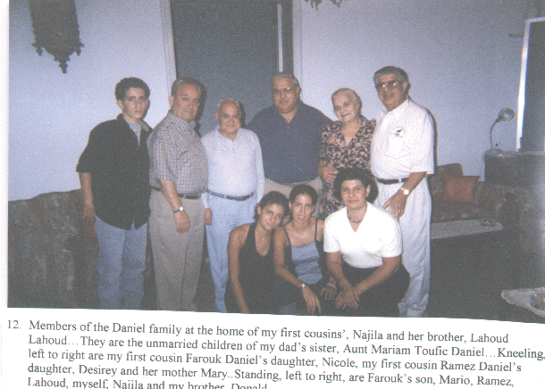
That evening, we were dinner guests at the home of my first cousin, Najila Lahoud and her brother Lahoud. That’s right, his name is Lahoud Lahoud. The house they occupied was the one in which my grandmother had lived or spent her last days. From the verandah, one can look down the mountain and see the city of Beirut and the Mediterranean Sea. In the 1930s, my father brought his mother to live with him in America. But she became homesick within one year and wanted to return to Lebanon. The main reason she gave was she wanted to be able to sit on her verandah and look down on the Mediterranean. After seeing the view for myself, I could understand why.
Najila is in her 70’s and she did all the cooking herself. She was so happy to have the opportunity to meet her first cousins and felt that having us for dinner was the least she could do. She looked a lot like my late sister, Dorothy -- same build and mannerisms; but then again, many of the cousins I met looked like one or another of us. That’s the Daniel genes at work, I guess.
Wednesday was to be another very busy day. That morning, Antoine Abi Ghosn and his wife Jacqueline Massabki took us on a tour which was to include visits to the castle of Moussa, the medieval town of Deir al Qamar and the president’s summer palace, Beiteddine. It was to be a day spent enjoying parts of Lebanon we had not yet seen.
We had earlier met Antoine and Jacqueline in Mannington in 1992 when they were visiting some of their relatives here. Although we are not related, Antoine’s Uncle Joseph Francis was married to my mother’s first cousin, Labibe Raad. One day during their visit to America, they needed transportation to visit one of their relatives in a nearby town and I volunteered to drive them. They never forgot! As soon as they found out I was in Lebanon and where I was staying, they stopped by to visit my brother and me and offered to take us on a tour. Jacqueline is a prominent Lebanese lawyer and author of a novel entitled “Memory of the Cedars.”
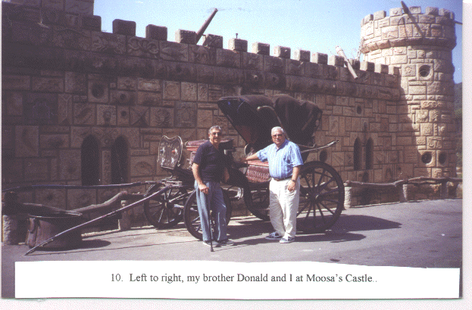
Our first stop was at Moussa’s Castle. The castle, itself, is perched upon the side of a mountain and is something to see. Each stone of the castle has a carving on it and inside are replicas of ancient village life and people. I was told that Moussa, who is still alive, was a school dropout. The teachers thought he was not intelligent enough to complete school, so he quit. To prove that he was not lacking talent, he built this castle, including a surrounding moat, with his own hands. One look at it and anyone can see that he was a talented architect and stone mason. Although we did not take the time to tour the inside, we saw brochures that depicted the contents and we marveled at the talent this man displayed to prove a point.
Next, we visited the town of Deir al Qamar. It is probably little changed from the middle ages when it was once the capital of Lebanon. It is the hometown of the famous Chamoun family. One member, Camille, was president of the Republic of Lebanon in the 1950’s and head of one of the Christian Resistance during the war in Lebanon. His son is the present mayor of the town and very active in Lebanese politics. The large plaza, which rises a foot or two above the street, is fringed with shops selling all types of merchandise ranging from clothing to souvenirs. Across the street is a Lebanese Army military post. There is an old Moslem Mosque, a leftover from the days of Turkish occupation. It is no longer in use but now serves as a tourist attraction. The Maan family, and its most famous member Emir (Prince) Fakhr ad-Din, ruled Lebanon in the Middle Ages. The Maans made Deir al Qamar famous.
Beiteddine was to be our next and last stop for the day. It seems as if most of the important sites in Lebanon are perched upon or near the top of mountains, and Beiteddine was no exception. We would have liked to meet the President of Lebanon, Emile Lahoud, but we knew he would not be at the palace. There were too many political problems keeping him in Beirut.
Members of the Lebanese Army guarded the entrance to the palace but we had no trouble entering. The palace itself is both Middle Eastern and Italian in architectural style, having been designed by Italian architects. On the outside are many manicured lawns with trees and shrubs and in the center a large courtyard with a beautiful fountain. National and international plays and music festivals are held here in the summer. The stone walls inside the palace are massive. The floors are made of brick or stone. Also, in the rooms that were stables in days of old, are found mosaics that were excavated from the Byzantine Church at Jiyye, the ancient city of Porphyrion among others. The Druze leader, Walid Joumblat, brought these to the palace during the war in Lebanon. Some of the mosaics were on the floor and others were on the walls. In another area of the palace is a replica of a room from the house of Kamal Joumblat, the late Druze leader. Much damage was done to the palace during the war but it is now being restored to its former splendor. Also within the palace are museums and many other attractions. We were running out of time and did not get to see of the rest of the palace, but what we did see was worth the visit.
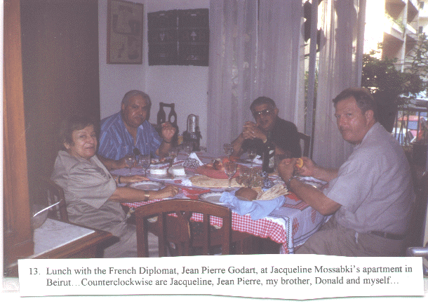
We had lunch at Jacqueline and Antoine’s apartment in Beirut and we were to be joined by a French diplomat Mr. Jean Godart. Jacqueline treated us to smoked salmon and assorted side dishes, fruit, French cheese and a wine from the Bekaa Valley.
That evening we were invited to the home of Lodi Madi, wife of my late first cousin, Toufic. As with all the invitations to my brother Donald and me, this included the family of our hosts, Ramez and Mary Daniel and the family. We had already met Lodi’s daughter-in-law, Cathia, at Najem Madi’s house when we first arrived in Lebanon. We had never met the rest of the family and they were all there, including her niece Teresa, daughter of her late brother-in-law George Madi. Three of the Lodi children and their fiancées were there. There were the delicious mezzes, including the little meat-filled samboosik pastries, and main courses which she chose to please us. This was a chance for us to get acquainted with the family of one of my Aunt Susan’s children, Toufic. Aunt Susan’s children were my mother’s favorites in the old country. My mother worried about them constantly until the day she died. This is the family that my mother turned over all her property rights to so that they would have a home and property of their own. If she is looking down from heaven now, I’m sure she would be pleased at how well this family turned out. They are all such beautiful people. During our visit, we learned that two of the young Lodi adults were going to be married this year.
On Thursday, we visited Antoinette Madi Karam, who is related to our first cousins in Connecticut. Although not related to us, she is a first cousin to the children of my Aunt Catherine Raad Madi. Aunt Catherine was married to Antoinette’s uncle, Elias Madi. Simply because she had visited with her cousins in Connecticut and had enjoyed her stay with them, she felt as if she had to reciprocate by showing us a good time while we were in Lebanon. She insisted on taking us on a tour of some of the sights in Lebanon and we accepted her offer.
The tour took us to one of the most famous landmarks in Lebanon, the Shrine of Our Lady of Lebanon at Harissa. I was familiar with the shrine, having seen pictures of it. I also wear a religious medal with Our Lady of Lebanon on one side and the emblem of a cedar on the other which my mother brought me after her visit to Lebanon in 1960. But to actually be there at the site was an experience I will never forget. What a beautiful, well manicured setting it was, situated on the crest of a mountain overlooking the city of Jounieh and the Mediterranean Sea.
There is a spiral stairway encircling the outside of the shrine and leading to the top where one can look out over some of the most beautiful scenery in the world. The view is spectacular! Inside the base of the statue is a chapel. Surrounding the whole area of Harissa and the statue are Christian churches of various denominations, such as Maronite, Orthodox and Roman Catholic. A visit to the shrine and surrounding areas is a must for anyone wanting to see some of the more important areas in Lebanon. From there we visited the church/shrine of Mar (Saint) Elias, where we were given some relics.
Then we went to the Maronite Patriarch’s Palace at Bkerke. This See is to the Maronite Church what Saint Peter’s Basilica and the Vatican in Rome are to the Latin Rite. The See or the Seat of the Maronite Syriac (Syro-Aramaic) Church of Antioch is located high in the mountains. The view is gorgeous. There is a large square in front of the entrance to the residence grounds where the buildings surround a beautiful plaza. We did not have an audience with the Patriarch because a demonstration was in progress. It seems as if the Patriarch is becoming increasingly assertive in his political rhetoric regarding the country. His predecessors did the same often in the past whenever the country was threatened and the people were suffering. At the demonstration, we observed an outspoken lady who was addressing a statement to the onlookers and the Patriarch. She was protesting against the government, not against the Church. She complained of government interference when her village church celebrated a Mass in honor of former Lebanese President Amin Gemayel and in memory of his late brother Bashir Gemayel, the assassinated president elect, who was assassinated by a bomb blast in 1982.
Before bringing us back to Ramez’s apartment, Antoinette treated us to lunch. For a change, we ate at a McDonald’s.
Friday was filled with sight seeing and visits with members of the Daniel family. Amin Daniel picked us up at Ramez’s apartment early in the morning for our trip to the Jeita Caverns. Amin, accompanied by his sister-in-law Hoda Daniel, invited all the Ramez and Farouk families. There were two full carloads of Daniels.
Because of their natural beauty, the Jeita Caverns could probably be classed as one of the wonders of the world. As with all trips in Lebanon, the drive was one of winding up and down mountains. At Jeita, the scenery was much different than what we had seen in the other parts of Lebanon. The mountains were lush and green with the foliage of a variety of trees. I remarked to my cousins that it looked much like West Virginia. To get to the grotto, one has to take a cable car from the parking lot up the mountain to the entrance. The grotto has two levels. The bottom level is a lake where one can take a boat ride and enjoy all the beautiful formations of stalagmites and stalactites created millions of years ago and new ones being slowly created today. The upper level contained chambers with thousands of beautiful formations. I have been in many caverns in the United States but this one has to be the most beautiful I have ever visited. What a shame we were not allowed to take pictures inside the cavern. The authorities are afraid the flash bulbs will
damage the formations. The grotto was closed to the public during the Lebanese war but is now again open to tourists. A German company renovated the caverns and installed new equipment making the sights more accessible to visitors. A visit here is a must for vacationers to Lebanon.
From here, we went to the ski resort of Faraya. On the way, at a place called Faqra, there are ancient ruins. The ruins lie on the side of the mountain and the view down to the valley is picturesque. Although little is left standing of the ruins, one can still see the remains of a large temple, altars and some rock-cut tombs. Many large rocks lie about, making it a very beautiful setting. On the other side of the road, I observed a shepherd’s hut, some goats and a small apple orchard. This is Lebanon. People who are shepherds are going about their business on one side of the road and on the other side, there are ancient ruins, going back thousands of years. On the way, we passed a natural bridge. If any of you are familiar with the Natural Bridge in Virginia, this one is much the same. It is so perfectly designed that for many years it was thought to be man made. But it is entirely a work of nature!
A couple of miles further and we began to thread our way down into the ski resort town of Faraya and to the restaurant for lunch. Near the restaurant was a district water-works plant that furnished water to all the nearby areas. There was a large stream pouring down the mountain and this was the source of water for the plant. The restaurant itself was very picturesque, not only in its setting, but also in its construction. The owner did much of the labor. The name of the roadside eatery was “Nabaa al Assal” (The Spring of Honey), aptly named. It was the most unusual restaurant we were to eat in during our stay in Lebanon, because it had a large fishpond built right into the floor of the outside dining area. The pond was filled with mountain trout and you could select the one you wanted to eat and tell the waiter how you wanted it prepared. They were delicious, especially fried.
Along the road above the restaurant was a little farmhouse where the lady of the house was baking bread on an outside oven (furn). Although my cousin did not buy any of the bread, he did buy a couple bushels of apples that were grown in the nearby orchard. After walking around and sightseeing near the restaurant grounds, we decided it was time to head back to Mansorieh. We were invited to dinner at the home of my late cousin, George Daniel, and his family.
At George’s house, his widow, Samia and her three sons, Maroun, Tony, Toufic and their wives warmly greeted us. Also there were my cousins Aziz and his wife, Marie; John and his wife, Leila; Laure and her son, George; Elias; Ramez, his wife, Mary, and their three children, Tony, Desiree and Dany; Farouk and his son Mario and daughter Nicole; and the Mayor of Beit Meri, Joseph Raad. He was the only non-Daniel present. Before dinner, we all toasted Joseph Raad and made him an honorary Daniel.
Of course, the mezzes and dinner were great but what I really enjoyed was the dessert. It was my favorite Lebanese dessert, “Awamat”, which my mother used to make on special occasions. If you don’t know what they are, I will describe them. They are little, round balls of dough that are deep-fried and then dipped in syrup made of water and sugar and fragranced with orange blossom and rose water. I ate eight of them and I’m diabetic. When I checked my glucose level the next morning, it fell in the normal range, believe it or not. I question whether Lebanese food and Arak are treatments for lowering glucose levels?
When this many Daniels get together and when there is an ample supply of Arak, beer and scotch, the stories begin to flow and the tales begin to be told. It reminded me of days of old when my dad and his brothers and cousins would get together and tell of the old days in Lebanon, especially tales of war between the Moslems and the Christians. One of my favorite tales concerned a great-great uncle of mine on the Daniel side of the family and his wife. It seems they were helping fight off some attacking Moslems, I believe it must have been in the 1860’s, probably not the earlier 1840 upheavals, and they had devised an ingenious way of defending themselves. In order to be able to fire on the advancing Moslems, they entered their outhouse,
cut holes in the bottom of the walls, stood in the “foul” trench, and fired “invisibly” in self-defense upon the enemy attackers. This tactic proved quite successful since the enemy could not figure out where the shots were coming from and were forced to retreat.
Our last day in Lebanon, Saturday, “Fearless Farouk” and Ramez took Donald and me to the section of Beirut where the goldsmith shops are located. I have forgotten the name of the area but it is in one of the older neighborhoods. There are many jewelry stores located here, many of which are owned and operated by Lebanese of Armenian descent. Years back, when the Armenians were suffering from religious persecution at the hands of the Turks, many fled to Lebanon where now they form an integral part of the community. Many of them are goldsmiths and it is to one of their shops that my cousins took us to find jewelry to bring back to our friends and relatives. My brother Donald was more interested in purchasing items than I was and while they were haggling with the goldsmith over prices, I walked outside to observe the happenings going on in the street.
As I mentioned, it seems that there are no traffic laws in Lebanon; and if there were any, no one pays them much heed. It was comical watching all the cars trying to go to the same place at the same time. I saw two police officers standing on an elevated pedestal in the center of the streets doing what I was doing, namely, watching the comical display of crazy drivers trying to all go to the same spot at the same time.
When we were driving away to come back to Mansorieh, one of the officers did blow his whistle at “Fearless Farouk”, who stopped. The officer, a very tall man, came up to the rolled-down window, placed his hand at the back of “Fearless Farouk’s” neck and very politely said: “’Amo (son), this is a dead-end street. You will have to go another way,” to which Farouk said “Okay.” After turning around and heading out on another street, I asked Farouk if the policeman was a personal friend of his, since he seemed so friendly. Farouk told me he had never seen him before. This is Lebanon!
Later Saturday night, “Fearless Farouk” and his family, Ramez and his family, and my brother Donald and I filled the two cars and went back down to Beirut. It was late, about 11 p.m., the best time to drive there because there is little traffic. We walked around the center of the city, looking at some of the buildings that had been restored since the war. We took many pictures but, unfortunately, the flash on our camera was not working and very few of the pictures came out. We felt perfectly safe in this area of Beirut. As a matter of fact, I felt safer here than I would walking around in the center of Washington, DC, probably. I’m sure there are areas of Beirut where it would be dangerous to wander around, but the same could be said of any city in any part of the world. We walked to Saint George’s Maronite Cathedral, which is being restored after the ravages of the war. Nearby, we saw the excavations of Roman ruins, which will be fully unearthed and kept in their original state as tourist attractions. We also toured the Place des Martyrs, which was named for the Lebanese nationalists who were executed by the Ottoman Turks early in the twentieth century. From here, we got back into our cars and went to the Corniche [coastal promenade] walkway which runs along the shoreline of the Mediterranean and from where we could see the famed Pigeon Rocks which lie offshore. Even at night this was a sight to see!
The entire downtown area and the areas along the seashore were humming with activity, especially the nightclubs and outdoor cafes. There were vendors with carts and coffee brewers selling their products along the Corniche. I only wish we could have spent more time seeing the rest of the city. It was late and we needed to get ready for our return trip home early Sunday morning.
I will not dwell on the departure because it was too sad an ending to a glorious ten days in beautiful Lebanon. It is the memory of arriving in Lebanon that I want to keep in my heart for as long as I live.
I will always remember the quiet mornings at breakfast on the verandah of Ramez’s and Mary’s apartment; the reawakening of fond, family memories. I cannot forget gazing up toward the mountain to Beit Meri, the hometown of my ancestors, as the village in all it’s beauty and splendor, stretches along the cliffs like some magical, fairy-tale city.
Farewell, Lebanon. Until we meet again!

EPILOGUE
Lebanon has many beautiful ancient ruins, shrines and scenery but the most beautiful asset it has can be summed up in one word -- it’s people. They are known around the world for their hospitality, and where there may be some other areas around the globe where the people are as hospitable, nowhere will you find them more so. I have found that the Maronite Lebanese feel obligated to extend hospitality to the guest, and they expect hospitality in to be extended to them as guests. It’s a matter of pride and is part of their character. It’s instilled in them from the day they are born. It was instilled in me by my parents. It’s part of our Maronite-Lebanese heritage.
The invitations to dinner that were extended to my brother and me were also extended to our host family, my cousin Ramez, his wife Mary and their three children. It would have been unthinkable to have invited one or two members of a family to dinner and not invite the entire family. Since we were staying with my cousin Ramez and his family, we were considered part of his family. Thereby, the invitations were always extended to all of us.
Another character trait I observed is their work ethic. I did not see any “bums” among my relatives in Lebanon. They all had jobs and took pride in their work. Many were in the skilled trades, such as carpenters, stonemasons, electricians, building contractors; some were in white collar jobs, such as sales representatives, accountants, office workers; others were in the professions, such as doctors, lawyers, pharmacists, school teachers, nurses; while others where involved in business ventures. All were working. All seemed successful. All had decent homes. And all were always striving to better themselves.
I did not notice any significant anti-American feelings among my people. There were a couple of instances when some individuals said that they felt the United States was always being too one-sided in favor of Israel to the disadvantage of its neighbors. I would have to agree with them. I am no great fan of Yasser Arafat, but I do feel the Palestinians have legitimate complaints and that the United States should be more willing to listen to them and help them form an independent nation of their own -- even if at times, it puts us at odds with Israel. Only then can we, as Americans, be considered fair and just in our relationships with the peoples of the Middle East.
Also, I felt there were some, though few in number, who wanted to blame the United States for all their current problems. These, I feel, are people who are burying their heads in the sand and refusing, for whatever reason, to look at the real causes of their problems. I think that the blame should be laid at the feet of some of their elected officials who have been bought and paid for by Syria.
There are still around 30,000 Syrian troops in Lebanon and the majority of the Lebanese, both Christian and Druze, as well as the more moderate Moslems, want them out. It’s not that the Lebanese people want to sever their relations with Syria. They don’t. They want to be considered a sovereign nation independent of Syria. They want good relations with Syria but as equals and not on a subservient level. This desire has been publicly expressed not only by the Patriarch of the Maronite Church, His Beatitude Mar Nasrallah Boutros Sfeir, but by the leader of the Druze sect, Walid Jumblatt, not usually one to side with the Maronites. Their statements have ruffled
some feathers, not only among some Moslems but also among some of the Maronite politicians who see the Patriarch’s interventions as diminishing some of their political authority. In the past, the Maronites looked more to their Patriarch for guidance than they did to politicians. I think some of the Maronite politicians fear this is happening again.
The presence of Syrian troops is one point of contention among most of the Lebanese. Another is the economic control over Lebanon by unrestricted importation of Syrian agricultural and manufactured products. This harms the Lebanese farmer and factory worker and costs jobs and a loss of revenue.
Another problem is a government policy which allows Syrian students to enter Lebanese colleges and universities without taking the college entrance exams and without holding academic qualifications required of Lebanese students. In some fields of study, like law and medicine, there are a limited number of classroom openings. Qualified Lebanese students are denied entry in order to accommodate the less qualified Syrian students. Students have demonstrated against this policy in recent weeks.
I personally believe too many politicians, including the president, Emile Lahoud, and other Maronite members of parliament; owe too much allegiance to Syria and the Hafez family. Whether it’s because they fear that the withdrawal of Syrian troops for one reason or another, I’m not expert enough to say. But I think the time has come for Syria to leave and, then, to become a good neighbor. The Syrians were invited for breakfast; they stayed for lunch; now they want to stay for dinner and the answer should be “No”!
But if Lebanon is to regain any of it’s former glory and respect from the other nations in the world, Lebanese Army troops must be the ones responsible for and in control of the country’s security -- not some independent faction like Hezbollah, whose allegiance is to Iran and Syria and not to Lebanon. The Lebanese Army must be moved to the southern border, where it should take and keep control. There are 50,000 army troops, I was told, so this shouldn’t be a problem. The problem is in the reluctance of certain politicians to do so for fear of Syria’s reaction.
At the present time, there is no love expressed for Israel by anyone I came in contact with. Where there was a time during the war when that may not have been the case, especially the time when Israel did come into Lebanon and help the Christian Forces defeat the Palestinians who were trying to take over the country, it is not the case now. I think they, the Christians, feel Israel betrayed them and that they were only interested in crushing the Palestinians in Lebanon, thereby helping the Israeli cause, and not in helping the Lebanese Christians. Once the Israelis destroyed the power of the Palestinians in Lebanon and forced Arafat to leave Lebanon, the Israelis withdrew, leaving the Christian Forces alone to battle the Moslem & Druze militants who were being supported by foreign volunteers from neighboring states. Also, in more recent times, Israeli bombs dropping on Beirut and damaging much of the infrastructure of the country, does not help them gain friendship among the Lebanese -- Christian or Moslem. I’m sure that everyday there is great resentment of Israel whenever the power goes off for four hours at a time because the power plant still has not fully been repaired since the Israeli bombing. I know for a fact whenever there was a power failure when I was in Lebanon and trying to take a shower or shave, I used profanity against Israel and the Israelis. It’s understandable.
The Maronites, these sturdy and energetic people of Aramaic/Syriac stock, remain steadfast in their beliefs and have never lost their identity as a people or a nation. They are the oldest group in Lebanon, predating the Arab Moslems and the Druzes. The Maronites opened relations with the rest of the world and this benefited Lebanon and its various communities, both culturally and economically.
I found the Maronite Lebanese to be concerned about their government and the problems it now faces as it desperately tries to recover from the 15 years of war and a 10 years of post war period of turbulence. There are no easy answers to the complexity of problems facing this nation and it’s people. However, I found the people confident that they can and will find the right solutions. This ability to recover from tragedies is characteristic of the Maronite-Lebanese nation. Over the centuries, it has withstood the onslaughts of the conquerors from ancient times to the present and has always had the ability to recover, rebuild and renew itself as a nation. It can and will do so now! This I do believe.
PAINTING THE VENERATED IMAGE OF SAINT SHARBEL:
SHERRY FANJOY AND THE LADIES OF SAINT SHARBEL
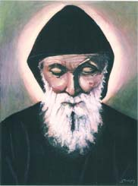
By MARI’s Staff
Two Canadian women have formed a group which shows its devotion to Saint Sharbel in a unique fashion. They meet each Tuesday and paint portraits of Saint Sharbel. This is the story of Brenda McDermott, née Peters (original name Soaib), who is of Maronite Lebanese descent, and Sherry R. Fanjoy, who is an artist and portrait painter of Saint John New Brunswick. They are the prime movers in this endeavor to spread devotion to Saint Sharbel.
Brenda's grandparents migrated from Hadsheet, North Lebanon, to Saint John, New Brunswick in the late 1800s. Because the Maronites at that time wanted to be accepted in their new communities, they did not send for a Maronite priest nor did they build a church of their own. They attended the Latin Catholic churches and were uninformed about their own particular spiritual and historical heritage. Brenda's father died when she was ten years old and she was raised by her mother who was French Canadian. Brenda always longed to know about the land of her father's ancestors and so she read the works of Khalil Jibran. This, along with printed literature and Lebanese and/or Maronite sites on the Internet, increased her curiosity and quest for more knowledge. A book about Saint Sharbel, which had been left in church by John Debly of the Lebanese community, impressed her and aroused more interest in the Saint, her spiritual heritage, and the land of Lebanon.
Because of her growing devotion, Brenda asked her artist friend, Sherry, to paint a portrait of Saint Sharbel from a photograph. Sherry was slow in responding to Brenda's request but finally began the portrait. Sherry described her feelings while painting the portrait as rapturous and somehow spiritual. Sherry claimed that she felt a spiritual bond with the Saint and wanted to know more about him. She read the copy of the book about Saint Sharbel which John Debly had left in church. Sherry said that learning about the Saint gave her life new meaning. Even Sherry's three-year old grandson Ethan recognizes Saint Sharbel's portrait which hangs on the wall and describes him, saying "he is God's friend".
Brenda was greatly impressed by the finished portrait that she wanted to learn to paint herself. During the past summer, she and a few other women began painting portraits of Saint Sharbel under the guidance of Sherry. Brenda says that Saint Sharbel has brought her peace and hope and that she wants his portrait hung on walls, far and wide. When Guita Hourani, Chairwoman of MARI, was visiting the Lebanese community of Saint John this past October, she participated in a
painting session. Hourani described the session as a wonderful experience which began with a prayer. “As we proceeded with the painting of the portrait”, said Hourani, “we were listening to chants from the CD ‘A Handful of Sand and Incense’ and talking about Saint Sharbel's life and spirituality…. The atmosphere was of joy and camaraderie, an experience that I would like to repeat.”
The group which meets each Tuesday plans to visit Lebanon and Saint Sharbel's hermitage in the summer of 2001.
In order to assist MARI in its mission, Sherry Fanjoy is donating her talent and labor to paint portraits of Saint Sharbel at cost and at no profit to herself. Those who wish to commission this unique work of art, measuring 12x16 inches, in oil or acrylic on canvas, and unframed, may do so for $175 US Dollars. This includes materials, shipping and handling, with the remaining 35% of the proceedings donated to support MARI’s mission. To order a painting and for other details, please write to Brenda McDermott, 897 Bleury Street, Saint John, New Brunswick, E2M 3H7, Canada. Her e-mail address is: dfanj@nb.sympatico.ca.
PORTRAIT OF THE ARTIST SHERRY R. FANJOY
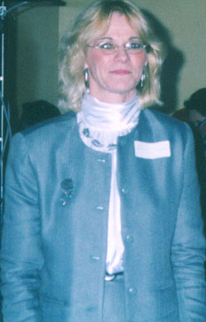
Sherry R. Fanjoy (Day) was born in Saint John, New Brunswick, Canada, in 1954. Because she married at a young age and then tended the family, she was not able to pursue formal studies to develop her talent in painting. However, she took art classes whenever possible. Her most valuable learning experience came from well-known and respected artists in Saint John. She joined the Saint John Art Club where she held positions as an art teacher, Vice President of the Club and later its President. Sherry participated in many group exhibits in Saint John and the province. Of particular interest is "The Festival By the Sea", an annual celebration that draws people from near and far; "Art Walk", which is a tour undertaken by the artists of Saint John; and "MiniArt Raffle", a fundraiser to promote art in the city. She also has exhibited solo. At one of her shows, a collector purchased all of her 21 paintings of boat scenes. Her job as a school bus driver in Saint John has provided her with many models for portraits which she prefers doing more than anything else. She loves the students and gives portraits of them as their graduation gifts. Sherry perfected her skills by doing portraits of her own children and those of her friends. Though she has received commissions to paint in various genres, her passion remains portraiture. Her preference is acrylics even though she paints in every medium. Of all her activities, she treasures her teaching art to juvenile offenders. She has described as most satisfying and rewarding her giving these young boys a constructive way in which to express themselves.

1
2
3
4
5
6
7
8
9
1
1
[
[
[
[
[
[
[
[

