MARONITE PATRIARCH SFEIR'S VISIT
TO HALIFAX, NOVA SCOTIA, CANADA
By Assad J. Chedrawe
Hallifax, N.S., Canada

- On March 24, 2001 at 1:45pm His Beatitude Patriarch Mar Nasrallah Peter Cardinal Sfeir, the 76th Maronite Patriarch of Antioch and All the East, arrived at Halifax International Airport, to pay a pastoral visit to his people in the Maritimes of Canada. Cardinal Sfeir brought his message of faith and peace to his flock, first to the USA and then to Canada.
- Accompanying Patriarch Sfeir as official members of his Visit to Canada were Maronite Bishops:
Bishop Joseph Khoury of Canada, and Their Excellencies Roland Abou-Jaoude, Patriarchal Vicar General, Francis Baysari of Diman, Mounjed Al Hachem of Baalbeck, Tanios Khoury of Sidon, Chokrallah Harb (retired) and Father Elie Madi, President of Caritas Lebanon. Two Lebanese television crews from the Lebanese Broadcast Corporation International and from MTV and one journalist from the AnNahar newspaper covered the historical visit.
- At the airport in Halifax, Maronites, Eastern Christians, guests and friends flocked to pay homage to His Beatitude, who had been on the road for over a month visiting his parishioners in one city after another from one coast to the other in the USA and Canada. His Beatitude graciously greeted with a handshake and a blessing everyone who came to receive him at the airport, a gesture that impressed everyone. This personal touch was something which Patriarch Sfeir would continue to do until the end of his visit.
- Prior to his arrival in the Maritimes, His Beatitude had visited several Maronite communities in Canada and had met with religious and political leaders, including a meeting at the Parliament in Ottawa and a private audience with the Prime Minister of Canada Jean Chretien.
- Upon his arrival in Halifax, Patriarch Sfeir indicated that he did not celebrate mass prior to leaving Montreal, and that he wished to celebrate one without more ado. This was an unexpected event and was joined by many who delighted in the celebration of the Eucharist which was not factored in the program.
- Preparations for the Patriarch's visit was undertaken by Father Kheirallah Aoukar, pastor of Our Lady Of Lebanon Parish in Halifax, with the assistance of local organizations such as the parish choir, the Canadian Lebanon Society of Halifax and The Diman Association Canada.

- Events were scheduled one after another in honor of the Prelate. A special evening was held at Our Lady of Lebanon Church. The choir, the youth of the parish along with the local organizations, presented a special cultural program, with recitals and folkloric dances. This was an informal event and the atmosphere was relaxed. The church hall was transformed into a gorgeous room full of light, flowers, culture, and joy. |  | 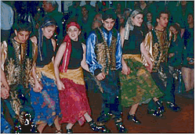  Young Maronites performing folkloric dances  Photo by author

 |  | 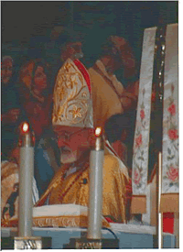  The Patriarch celebrating the Holy Liturgy at Our Lady of Lebanon Church in Hallifax  Photo by author | - On Sunday March 25 the Patriarch celebrated a Pontifical Mass at Our Lady of Lebanon Church. Among those present were many dignitaries and church officials, including Archbishop Terrence Prendergast of the Roman Catholic Diocese of Halifax, and Dr. John Hamm, Premier of the Province of Nova Scotia. There was a large number of Maritimers of Lebanese origin who had come from New Brunswick, Prince Edward Island, Charlottetown, Fredericton, Sydney, and Cape Breton. Also attending were two brothers from Our Lady of Grace Monastery, a Maronite order headquartered in Massachusetts and with a recently opened branch in Canada, who had made the weekend pilgrimage to Halifax to meet His Beatitude.

- The attendance at Mass was overwhelming. In anticipation of a huge crowd, a large TV screen and closed circuit system were installed in the church hall. Everyone was able to see the Patriarch and to follow the Mass.
- After the service, Father Kheirallah Aoukar presented His Beatitude with a carving depicting Our Lady of Lebanon Church in Halifax. It was the creation of a native Micmac Indian artist and was made from a solid piece of Nova Scotia maple wood.
- At the church, the Patriarch blessed the statue of the Blessed Mother, a replica of the one adorning the entrance of Bkerke, the Maronite Patriarch's residence. With his blessing, he inaugurated the building of a shrine to house the statue.
- The following were some of the notable events held in Patriarch Sfeir's honour: A reception hosted by the Lieutenant Governor of Nova Scotia, Myra Freeman, at the Government House on Sunday March 25th; a lunch hosted by the Honorary Consul of Lebanon, Mr. Wadih Fares, and his wife Cathy on Monday March 26th; and a grand banquet for the community and guests which was held on Sunday afternoon in the Commonwealth Room of the Westin Nova Scotia Hotel. Here, Patriarch Sfeir delivered his main speech, a message of love, hope, faith, and resilience, in the presence of hundreds of parishioners, visitors, and friends.
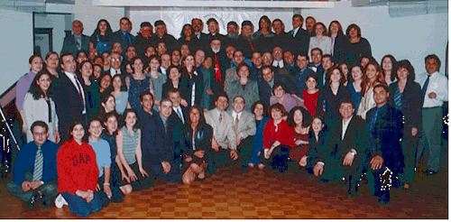
A Commemorative photo woth few members of the community.
Photo by author
- It was a rousing speech! Those in attendance arose, applauding and cheering every word the Patriarch uttered. First, he described his visit to Canada and the USA. Then he expressed his joy and pleasure upon seeing his flock, so far from their homeland, and still maintaining such a strong faith. With humility, he thanked all who had come out to see him and for the warm and joyous manner in which he had been received. He brought up the issues of peace in Lebanon, freedom, human rights and sovereignty which are important to the Maronites and all Lebanese citizens especially. He spoke of the need for both the withdrawal of Syrian troops from Lebanon and the reduction of Syria's influence over the Lebanese government. He also talked about the role of those who had emigrated in keeping the faith, and their connection and responsibility toward their brethren and Lebanon.
- His Beatitude held private meetings with and received the love and esteem of visiting groups such as that from Saint Sharbel Church in Fredericton New Brunswick, Charlottetown Prince Edward Island. A special meeting was also held for the Canadian Lebanon Society of Halifax on Sunday evening where a numbered lithograph of the world famous Nova Scotian Champion Racing Schooner "The Bluenose" was presented to His Beatitude.
- Sunday evening saw a smaller somewhat more sedate gathering. An evening supper was held for all church volunteers and members of the welcoming committee. This was very relaxing night for Patriarch Sfeir. It provided the people who organized the activities for the visit the chance to meet and talk with their spiritual leader in a warm and more personal atmosphere.
- On Monday morning, His Beatitude began his day by celebrating the Liturgy at Our Lady of Lebanon Church. Once again the church was filled to capacity. After Mass, Patriarch Sfeir once again personally greeted his flock. However, something surprising occurred! The Patriarch was asked for his autograph several times. Young and old alike sought him out not only to receive a blessing, but again for his autograph. Signing autographs is usually reserved for rock stars and cinema superstars, yet here they were asking this humble priest for his. Everyone had become so enthralled and captivated by His Beatitude that they wanted a memento, something of his to remember him by. As he had done everyday since his arrival, he openheartedly obliged everyone.
- The Honorary Consul of Lebanon, Mr. Wadih Fares took Patriarch Sfeir on a personal tour of Halifax, and hosted a luncheon in his honor. Among the places visited was St. Mary's Basilica, one of the oldest, largest and most beautiful churches in Nova Scotia. Like all grand churches, St. Mary's has a rich history and houses a small museum which showcases the religious history of the church. A large number of religious artifacts are on display. Included among them are the Robe worn by His Holiness Pope John Paul II on His Visit to Halifax in 1984. Cardinal Sfeir was visibly impressed by this museum.
- The last event of Cardinal Sfeir's visit was the reception and community gathering hosted by the Diman Association Canada on Monday night at the Diman Lebanese Center.

- Prior to entering the center, a tree planting ceremony was held on the front lawn. Patriarch Sfeir placed a ceremonial shovel full of dirt at the base of the tree. This evergreen would serve as a reminder and a symbol of his visit to the center. |  | 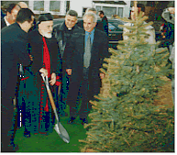  Patriarch planting a tree at the Diman Center  Photo by author

 | 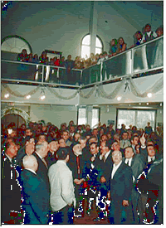  Patriarch admiring the mural of the Diman village at the Diman Center  Photo by author |  | - Upon entering the Diman Lebanese Center, Patriarch Sfeir received a most pleasant surprise. He was greeted with the sight of a huge mural of the summer residence of the Maronite Patriarchs -- the little village of Diman nestled at the foot of Mt. St. Simon overlooking Wadi Qannoubine. Amid the cheering and applause, Patriarch Sfeir admired the mural. He was clearly delighted!  - Next, a plaque commemorating his visit to the center was unveiled. It will be placed permanently at the entrance to the center in remembrance of his visit. Patriarch Sfeir was presented with a hand carved, painted and gold embossed icon of the Madonna and Child.

- A large contingent from St. Antonios Antiochian Orthodox Church, headed by Father Maximos Saykaly, shared the joy of this historical visit! They were present throughout the entire weekend and participated in the welcome for the man who is considered the Patriarch of all of the Lebanese people.
- Patriarch Sfeir, who represents the Maronite spiritual and national identity, left with his flock in Halifax a profound belief in their faith, a fervent conviction in the resurrection of Lebanon, and an individual sense of worthiness as God's children and the heirs of a heroic people.
- Those who had come out to see His Beatitude felt even closer after having known him better. He had stood next to them, and had talked and laughed with them! It was memorable. They were proud to be Lebanese or Canadians of Lebanese heritage. They were even more proud to be Maronites.

